

**School of InfoComm Technology**

**Agile DataOps**

Diploma in Data Science

Year 2 (2022/23), Semester 4

**ASSIGNMENT 2**

(40% of Agile DataOps Module)

**Deadline for Submission:**

**Presentation: Week 16-17, 30th Jan – 10th Feb 2023**

**Report: 27th Jan 2023 (Friday), 23:59 Hours**

|  |  |  |
| --- | --- | --- |
|  | Student Name | Student Number |
| 1 | Ambrish Krishna Muralitharan | S10223486G |
| 2 | Lim Wee Liang Kelven | S10221788K |
| 3 | Muhammad Nuriman Bin Rahim | S10227895A |
| 4 | Seng Chong Xiang | S10222597A |

**Penalty for late submission:**

10% of the marks will be deducted every day after the deadline.

**NO** submission will be accepted after 26th Dec 2021, 23:59.

Table of Contents

**1. Project Overview** 3

**2. Scrum Board/User stories** 3

**2.1 Ambrish** 5

**2.2 Chong Xiang** 5

**2.3 Iman** 5

**2.4 Kelven** 6

**3. Burn Up/Down chart** 6

**4. DataOps** 7

**4.1 Ambrish** 8

**4.2 Chong Xiang** 22

**4.3 Iman** 28

**4.4 Kelven** 42

**5. DataOps Scalability** 59

**6. Visualisation** 60

**6.1 Ambrish** 60

**6.2 Chong Xiang** 63

**6.3 Iman** 66

**6.4 Kelven** 69

**7. Reflection** 71

**7.1 Ambrish** 71

**7.2 Chong Xiang** 71

**7.3 Iman** 72

**7.4 Kelven** 72

**8. Website Links** 72

## **1. Project Overview**

There is a lot of information on the Internet and it is difficult to discern which are true and analyse market trends. The objective of this assignment is to provide a Data as a Service (DaaS) platform to our target audience, house buyers, and provide valuable insights like housing trends using credible data.

This was accomplished using the Agile framework, Scrum, and DataOps in addition to using software like Trello, Airbyte, PostgreSQL, Microsoft Azure, and Power BI. We are part of a DataOps team at Unicorn, a start-up building a DaaS platform, targeted to provide data sources onto the platform. The client can reach out to Unicorn to consume its DaaS.

During assignment 1, we were tasked with creating an inception deck showing our roadmap to complete assignment 2. Throughout this assignment, we have accomplished the following:

* Sourced relevant datasets
* Cleaned the datasets
* Connected the datasets to Azure
* Created dashboards to discover insights and trends
* Created a website to showcase our findings

## **2. Scrum Board/User stories**

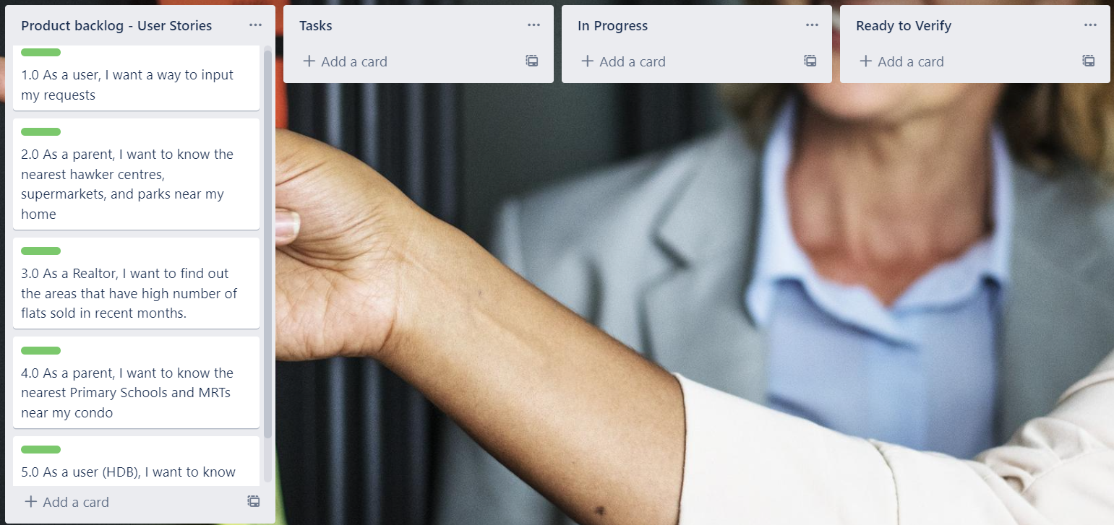

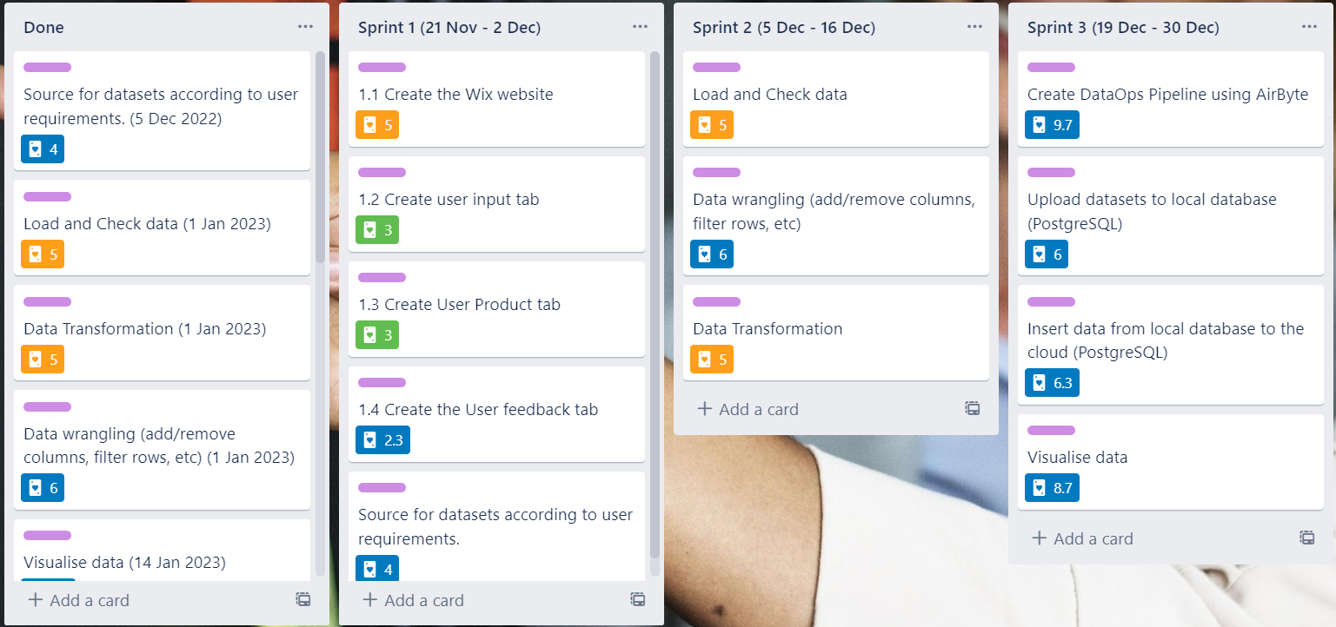

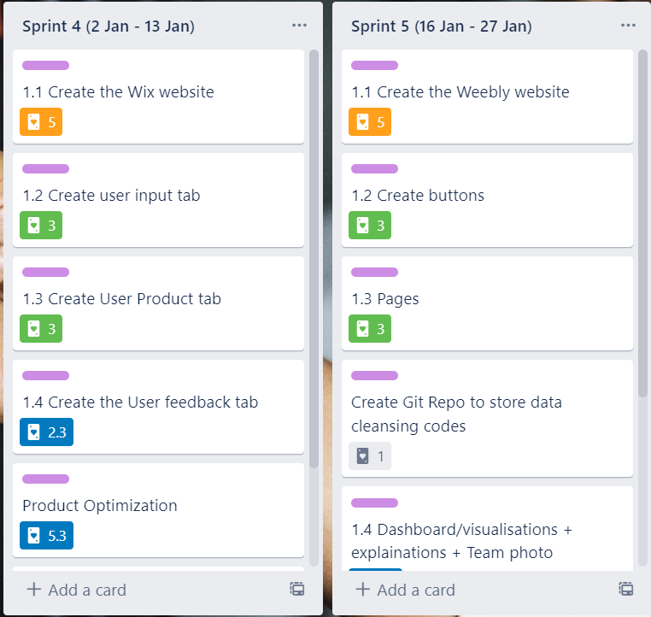

The images above show our Scrum board on Trello. During the start, we created the lists Product Backlog - User Stories, Tasks, In Progress, Ready to Verify, and Done. During our first sprint planning, we ideated a user story for each of us. When ideating, we wanted to cover a spectrum of house buyers and we decided on parents/families, HDB, and realtors. After the user stories, we came up with tasks that can help answer the stories. However, since this was our first time using a scrum board, we were unsure of what tasks to put in.

During the second sprint meeting, we remade our user stories and tasks which cleared up some of our confusion. After planning out the new user stories and tasks, we proceeded to allocate points using Planning Poker.

For every sprint, we created a new list for that sprint and duplicated the tasks. One set of tasks is to be moved to the In Progress list, while the other set would be in the sprint list.

When a task is completed, it will be moved to Ready to Verify. And after one of us checks the quality of the completed task, it will be moved to Done along with a timestamp.

## **2.1 Ambrish**

User Story:

As a parent, I want to know the nearest Primary Schools and MRTs nearby.

As parents, it would be beneficial for my children to have to travel less when going to school. Moreover, as a first time applicant, it would be beneficial for us to move closer to a school to satisfy the school’s distance from home criteria, which also plays a role in the admission of students to the Primary 1 level. Furthermore, it would also be beneficial for our home to be situated near a MRT station to make travelling to areas such as workplaces and relatives’ homes easier and more convenient for us. Therefore, I want to make use of Unicorn’s services to find the areas of homes that are best suited for us as a family.

As my client would require housing advice that entails the locations of primary schools and MRTs, it would be best to provide the final product in terms of a dashboard created with Power BI that can be published on a website. To do this, I would first need to compile housing datasets along with their respective locations, followed by location datasets for primary schools and MRTs. Then, I would pipeline the datasets using Airbyte and store them in a PostgreSQL database for cloud storage. I will follow up on this by conducting the various Data Wrangling, Cleansing and Transformation techniques required using Jupyter Notebook, before finally making use of Power BI to conduct Data Analysis and bring context to the datasets. Finally, I will publish this dashboard created by me on the group website that will be created using Weebly.

## **2.2 Chong Xiang**

User Story:

As a Realtor, I want to find out the areas that have a high number of flats sold in recent months.

From a financial benefits point of view, I, as a realtor, would want to close as many opportunities with my clients as possible. Therefore, it is crucial that I have information on recent housing data such as regions with the most number of flats sold, recent housing market trends, flat types that are highly pursued, and market demands for government housing and private housing (Condominiums, Landed properties and Others). This keeps me updated with all relevant housing information in a detailed yet concise manner and creates more business prospects from then on.

​

On another hand, I need to know the correlations between factors affecting the potentiality of the property. My client would be someone who is looking for houses for settlement purposes or investment purposes. Thus, it will be convenient if I can provide them with houses which best suit their needs and requirements at one glance.

## 

## **2.3 Iman**

User Story:

As a user (HDB), I want to know what is the remaining lease period for a certain HDB area.

What is the length of the lease for a HDB flat? The length of the lease for all HDB flats starts at 99 years. It serves the needs of the owners and children while keeping in mind that the land can be recycled for future generations. Once the flat's lease life has ended, HDB will then recycle and rebuild the flats into newer flats for future Singaporeans.

## **2.4 Kelven**

User Story:

As a parent, I want to know the nearest hawker centres, supermarkets, and parks near my home.

When raising children, parents would want hawker centres, supermarkets, parks, and playgrounds to be within arm's reach as this makes raising children more comfortable. A nearby hawker centre ensures parents can have a quick meal before attending to their child. A nearby supermarket ensures essential goods are accessible. And a nearby park or playground provides a convenient venue for recreational activities.

Hence, flat prices are not the only elements parents think of when looking for homes. Assuming every HDB is equally near to schools and MRT stations and each flat is equally priced, parents would next look for homes with the most nearby facilities (hawker centres, supermarkets, parks, and playgrounds). If one facility closes, there are still many others to go to.

## **3. Burn Up/Down chart**

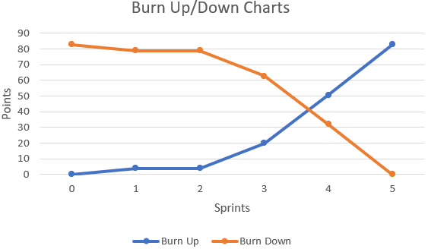

There were a total of 83 story points across all our tasks. Sprints 1 and 2 were the least productive because we procrastinated early on and other assignment deadlines. Sprints 4 and 5 were the most productive because we had greater urgency and the assignment was also finished.

Sprint 1 focused on sourcing datasets according to our user requirements. We wanted to create a website where users can input their requirements, and wanted to connect the PostgreSQL database to the website. But we pushed this to the later sprints instead as sourcing for datasets took some time. As the assignment had just started, we were confused about what the assignment objectives were. Thus, there was no progress on creating either the website or setting up the connection to PostgreSQL. We only managed to source for our respective datasets.

Sprint 2 focused on data wrangling. With our three datasets each, we wanted to clean, add or remove columns, filter rows, etc. The cleaned data will then be used later on when creating our dashboards. Some of the tasks were delayed as we had other assignments, hence little progress was made too.

Sprint 3 focused on pipelining our data to the Azure database as well as creating our dashboards. There were 2 pipelining methods, the first is using week 7’s tutorial on the Airbyte UI, and the second is using week 8’s tutorial on Octavia CLI. Everyone followed week 7’s tutorial. But for Iman, Kelven, and Chong Xiang, their Airbyte crashed. Ambrish was the only member with a working Airbyte. Kelven created the Azure database, everyone whitelisted their IP addresses, and Ambrish helped us upload our datasets into the database. To test if the connection succeeded, we opened up PgAdmin 4 and Power BI and tried connecting to the database. During this sprint, Sprint 2’s remaining tasks were completed.

For Sprint 4, we decided to continue working on our website. During this sprint, we researched how we could connect PostgreSQL to Wix, only to realise that we needed a third-party application to do so. To use this third-party application, we needed a paid membership. Thus, the website idea was discontinued. Despite this setback, we continued finishing our other tasks such as creating our dashboards and connecting the last of our datasets. Some of us were still troubleshooting our Airbyte but to no avail.

During our Sprint 5 planning, we decided that we could use a website to showcase our findings instead of allowing the user to input their requests. We did not know if the Wix tasks should be moved to “Done”, so we renamed the tasks instead. Wix does not allow multiple concurrent editors, so we moved to Weebly to create our website. Since this was the last sprint, we created new tasks such as creating a GitHub repository to store our codes used to clean the data, create presentation slides, and finish our report and allotted points for them. The Weebly website showcased our dashboards, team members' photos, LinkedIn accounts, and personal websites. Kelven created a GitHub repository, and finally, we did our final checks for the product.

## **4. DataOps**

DataOps may sometimes be confused with DevOps. While the concept of DataOps is inspired by DevOps, there is a clear distinction between the two. The key focus of DevOps is on making the deployment as automated as possible. This allows software engineers to constantly build new features and deploy them easily. DataOps involves the combination of agile development practices to create, deliver, and optimise data products, quickly and cost-effectively.

Using DataOps helps the team deploy data pipelines quicker, enhance decision making, collaborations across teams, and managing built-in environments

Testing in DataOps enables the data team to deploy with confidence, reduces bureaucracy, make development a more lightweight process, reduce cost, and empower data owners, business users, and the development team

The following are the different stages of the DataOps lifecycle our group have undergone in this assignment:

* Plan
  + Firstly, our group started off by setting up our scrum board using Trello. This allows for detailed and simultaneous planning to be carried out online. The first thing we did is to set an objective for each sprint and subsequently, defining the individual story points for each of the sprint. For example in Sprint 1, our group has decided to focus on “Sourcing and validating data”. Thus, each of us started looking for relevant and useful datasets to our stakeholders.

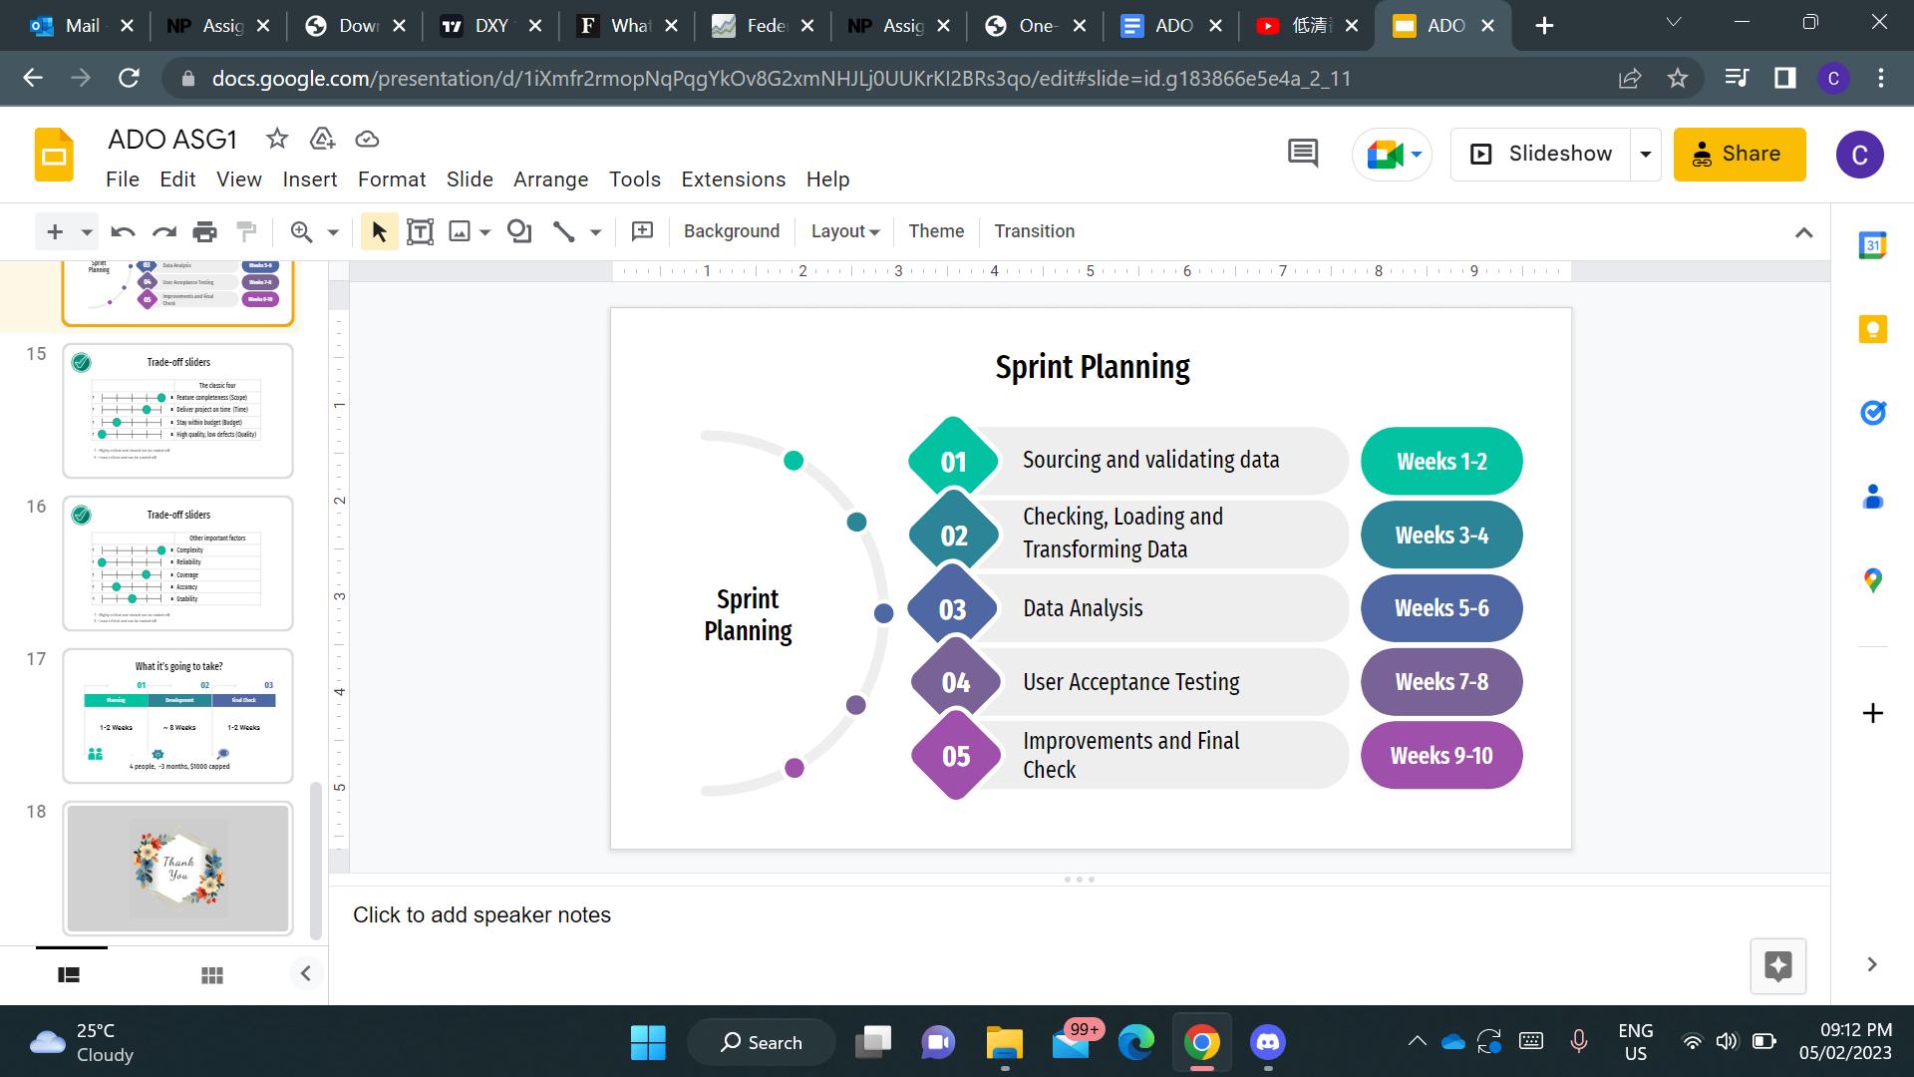

* Create
  + Each of us created our own personal PostgreSQL server in Azure. We all created our own database but as for this Assignment, we only used one database from one of our team members. Once the database was set up, our datasets can then be uploaded into the database. Firstly, Airbyte was also set up by all of us to upload our datasets into the user interface and load the data into the PostgreSQL database. Once we have uploaded our datasets through Airbyte into PostgreSQL database, we can then see the datasets through PgAdmin4, a software that lets us manage our PostgreSQL database. Visualisations were also created through Microsoft Power BI, a software that lets us create visuals with the primary focus on business intelligence. Finally, we created our own website to showcase our visuals, the explanations of the visuals, and websites and linkedin of each team member.
* Test & Fix
  + After sourcing our datasets, we tried connecting to Azure using Airbyte. All of us encountered issues doing this. To resolve our problems, we asked each other if we encountered the same problems, we asked other teams, and we asked our lecturer. When creating the visualisations, we also checked with each other whether our chosen visuals are justified which improves the quality of our dashboard.
* Continuous Integration
  + Ensured that the visualisations we have created are relevant and helpful to our stakeholders. In addition, the visualisations should have helped to solve their problem statement which each of us came up with at the start.
* Monitor
  + We attempted connecting PostgreSQL and Power BI to our Azure database. If our pipelines are working, our datasets should be seen after the connection.

## **4.1 Ambrish**

In Sprint 1, when we first began this assignment as a group, each of us were first tasked to source for datasets for our own individual user story. For myself, the user story is “As a parent, I want to know the nearest Primary Schools and MRTs near HDBs”. Therefore, for this user story, I had to source for datasets involving locations of primary schools, locations of MRTs and last but not least locations of each HDB building. Hence, I did so and compiled 3 datasets that are called as follows:

* primaryschoolsg.csv
* mrtsg.csv
* hdb_geoloc.csv

After doing so and conducting other tasks in Sprint 2, we moved on to pipelining the data in Sprint 3. To upload my datasets into the Azure database, I followed the Week 7 Tutorial provided regarding Airbyte. During the first week of lessons, we were asked to download software such as WSL, Ubuntu, Oh-my-zsh, Anaconda, and Docker Desktop that would aid us for this assignment. We were also asked to download PostgreSQL and PgAdmin 4.

As all the required software was already present, my group did a test run by first creating our own personal databases and connecting to them. The steps to do that are as follows.

Firstly, go to the Azure portal. Open the hamburger menu that is present on the top left of the screen and click on **Create a resource.**

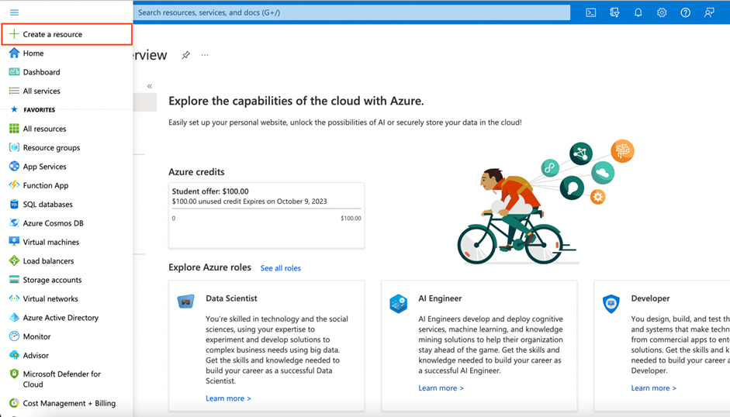

Next, select **Databases** from the menu on the left and click on **Azure Database for PostgreSQL**. In the following tab that pops up, click on **Create**.

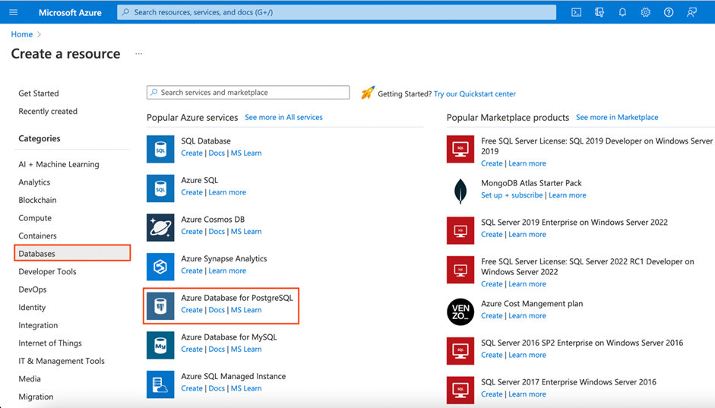

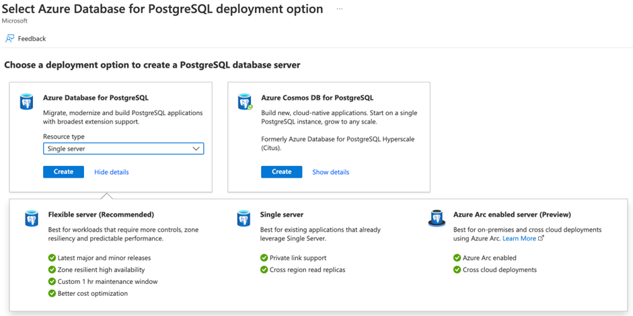

You will then be seeing a page where you can configure your own PostgreSQL server.

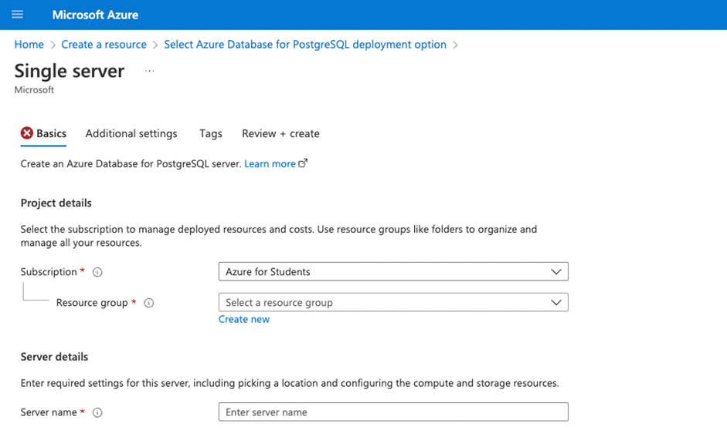

For the name of the **Resource Group**, I used np-dataops-ambrish as it was for my personal test run.

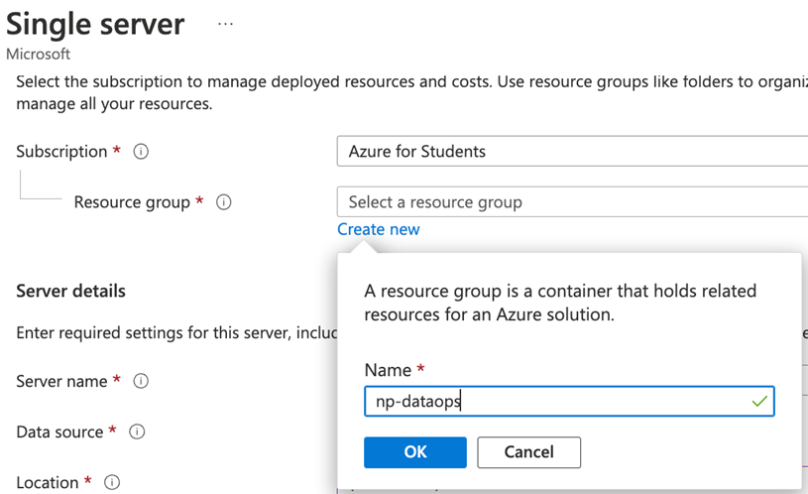

Under **Server Name**, I used **np-dataops-ambrish**. Then, under **Compute + Storage**, click on **Configure** server.

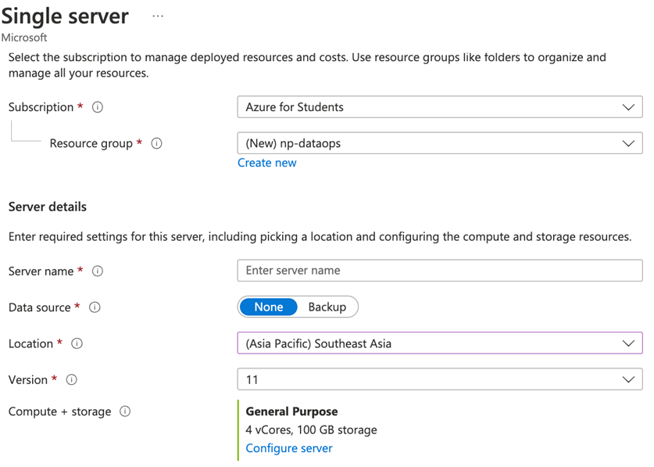

Afterwards, you will be brought to a page that looks like the one below to configure your server’s compute and storage.

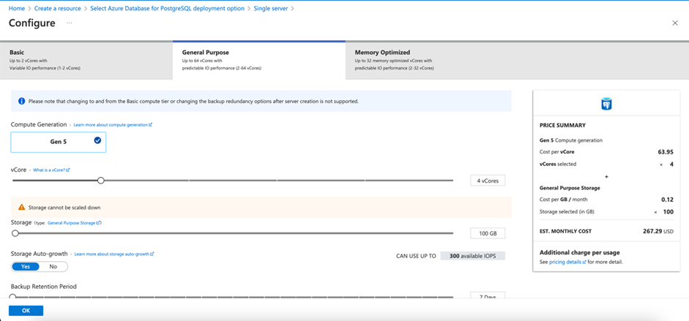

To ensure cost efficiency, we will choose the Basic option on the top tabs. Move sliders to get the following

For the **vCore**, keep it to **1x** vCore.

For the **storage**, keep it at **10x** GB.

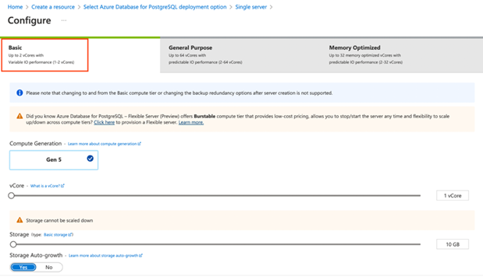

You should be able to see the price summary on the right. It should be somewhere close to the cost that you see above. For the other options, leave as it is. Click on the Ok button at the bottom left and you will return to the previous page.

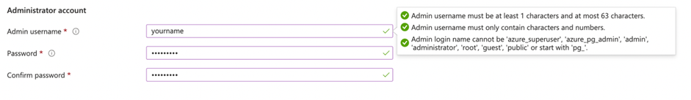

I then set my username as **AmbrishKrishna@np-dataops-ambrish** and also set my own password. Then, click on the **Review** button, followed by the **Create** button that shows up.

Once the server is ready, click on the **Go to resource**. This will bring you to the credentials page for your Azure PostgreSQL database server.

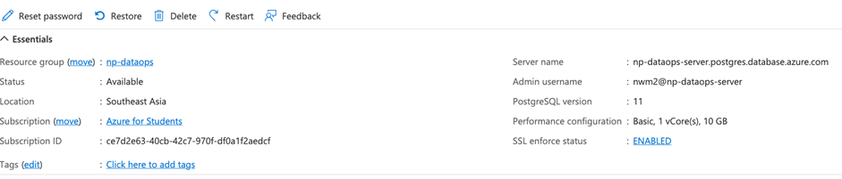

Next, click on the hyperlink on **SSL enforce status**. This will bring you to the page below where you are able to configure the Connection Security. Click on this hyperlink to add your current client IP address so that it can be whitelisted. This will allow your machine’s IP address to be allowed connection to the Azure PostgreSQL database server.

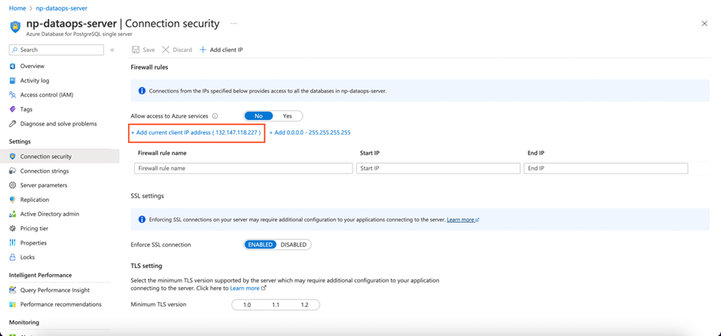

After creating the group database, open up WSL as administrator and install Airbyte using the following commands into the WSL terminal.







Once “docker-compose up” has been executed, the text seen in the image below will appear while Airbyte is loading.

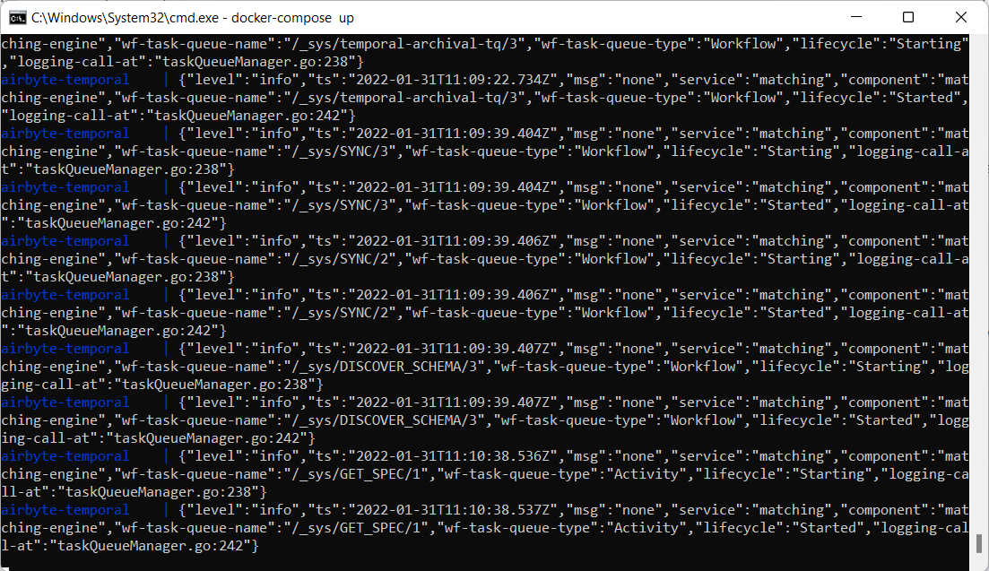

After a few minutes, the windows will show Airbyte logo and the message “Now ready at <http://localhost:8000>”.

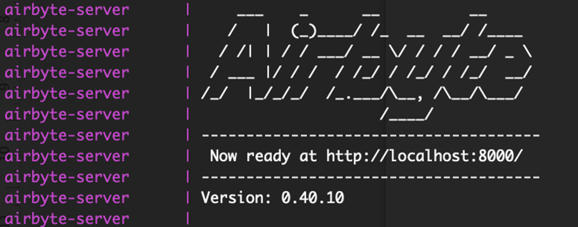

After entering the link, I entered “airbyte” for the **Username** and “password” for the **Password**.

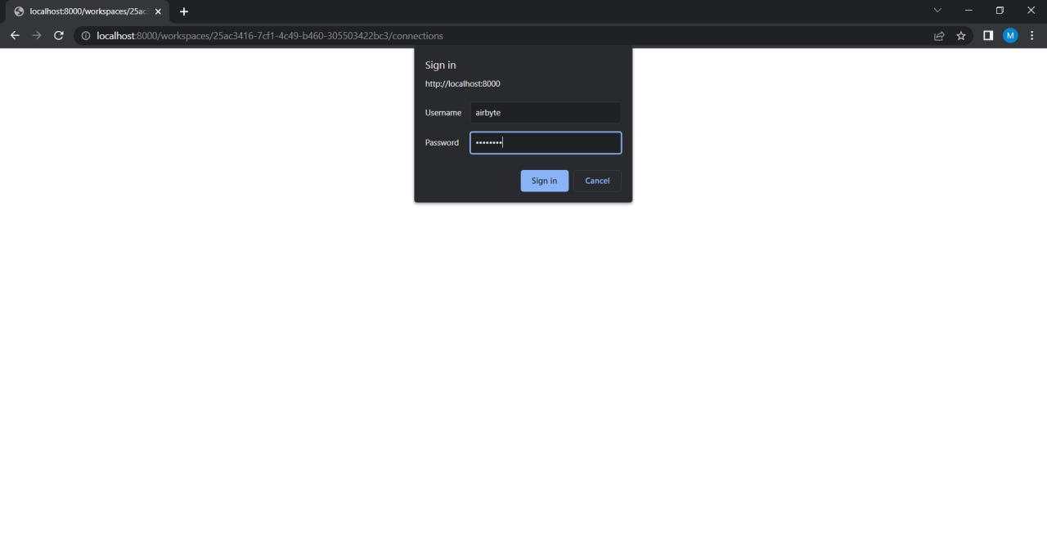

As it was my first time using Airbyte, I was prompted to enter my email and select optional fields. After doing so, I clicked “Done”.

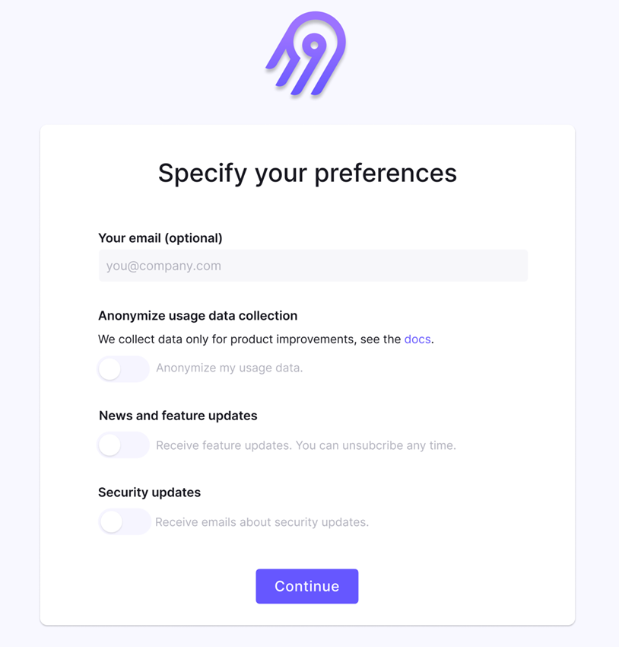

This is the welcome page for Airbyte that I saw.

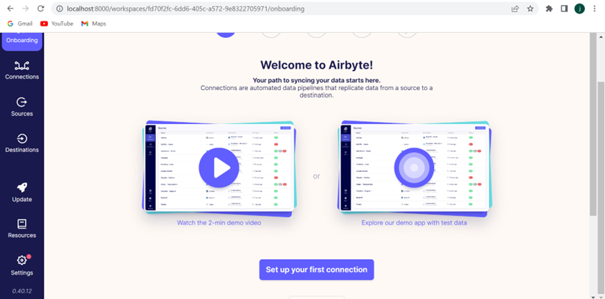

As Airbyte is now set up, the csv files have to be copied into a temporary folder.

Firstly, as my directory was in System32, I wanted to change it to Downloads to make the process of copying and adding the datasets to the airbyte folder easier. Hence, I used the following code.



Secondly, copy the file into the temporary folder using sudo cp file_name.csv /tmp/airbyte_local .

To pipeline the dataset to the database using Airbyte, a **Connection** has to be made between a **Source** and **Destination**.

To create a Source, in the **Sources** tab, I clicked on **+ New Source**.

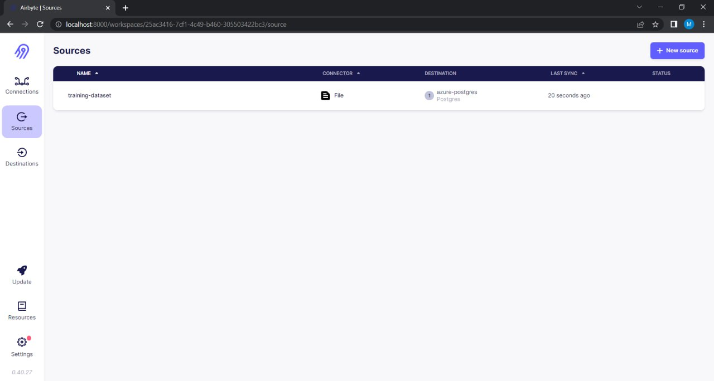

Then, I selected **File** for the **Source Type.** For **Source name**, it is the name of the source when you see it in Airbyte. Hence, I entered the csv file name for easy reference. For **URL, I** entered the location where the file is stored. In this case, the file stored in/tmp/airbyte_local. Lastly for **Dataset name**, it is the table name in the database once it is loaded. I entered the csv file name for easy reference again. Once the form is completed, I clicked **Set up source** to test the connection.

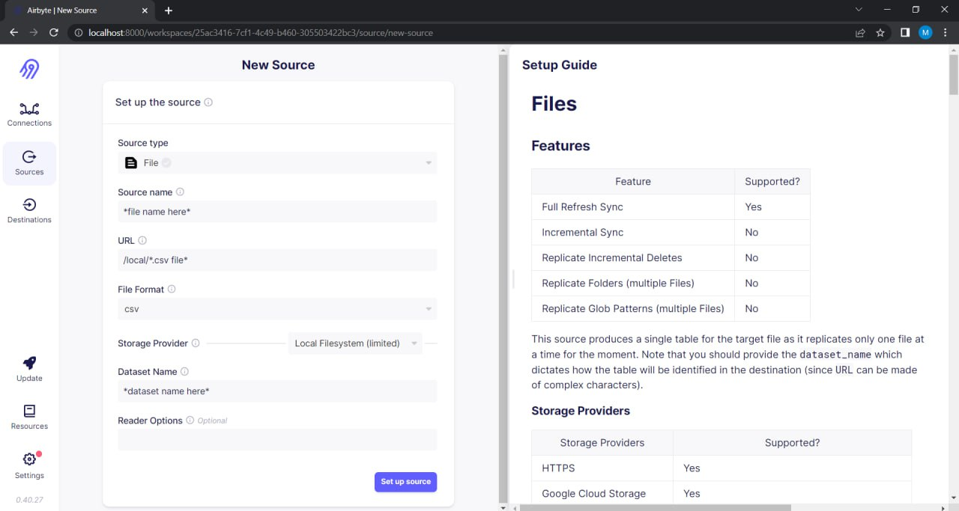

Once the source has been created, the following page will be shown. As I was using the **training-dataset** provided in the Week 7 Tutorial, you can see that the dataset has been added successfully.



I then connected to the destination which is np-dataops-ambrish by clicking on the **+ New Destination** under the Destination tab. I then filled in the necessary information and succesullu connected to the destination.

As the test run was successful, I repeated the entire process again. However, this time I did not create a new resource. Instead, I used the resource already created by my groupmate Kelven called **np-dataops-group3.** Also, I uploaded my own individual datasets required for this assignment instead of the training-dataset.

As my groupmates had some technical difficulties when pushing their own individual datasets to Airbyte, I helped to push their datasets as well. Hence, this is what the final Airbyte destination page looked like.

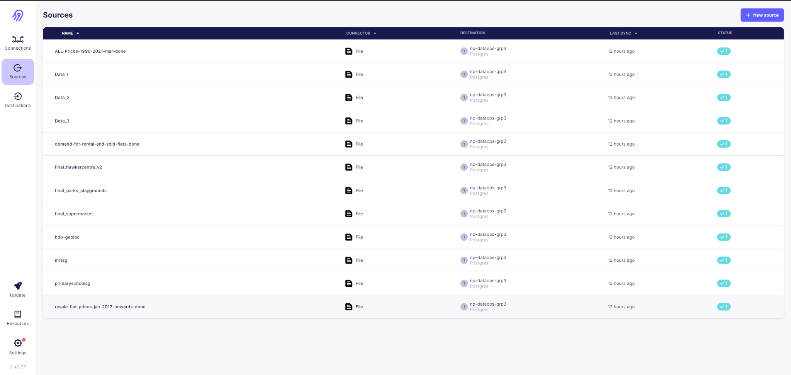

As all the datasets have now successfully been added to the destination in Airbyte, I went to PgAdmin4 to test the connection.

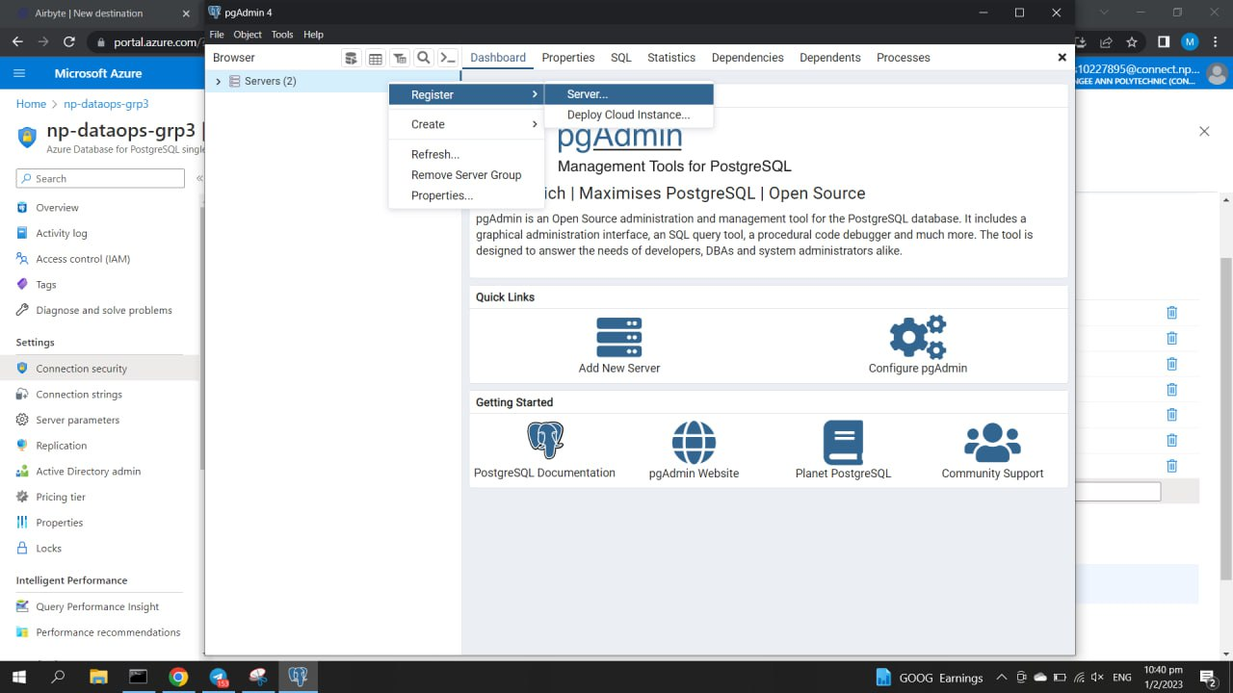

Once PgAdmin 4 is loaded, I right-clicked on **Servers**, selected **Register**, followed by **Server.**

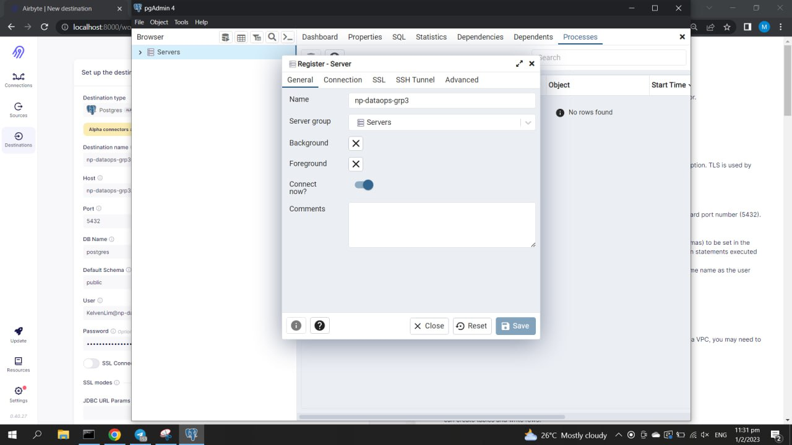

The name of the server will be “np-dataops-group3”

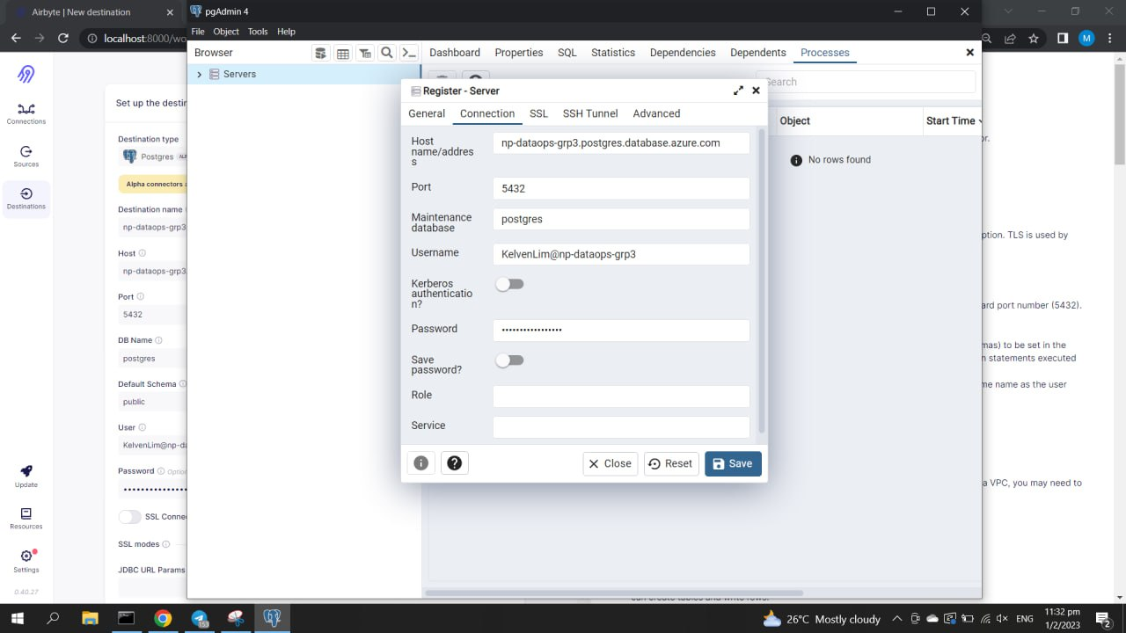

I then went to the **Connection** tab, and filled in the necessary credentials. As my groupmate Kelven was the one who set up the resource, we had to use his credentials to do this part. The following is the credentials set in PgAdmin4.

Host: np-dataops-personal.postgres.database.azure.com

Port: 5432

Maintenance database: postgres

Username: KelvenLim@np-dataops-personal

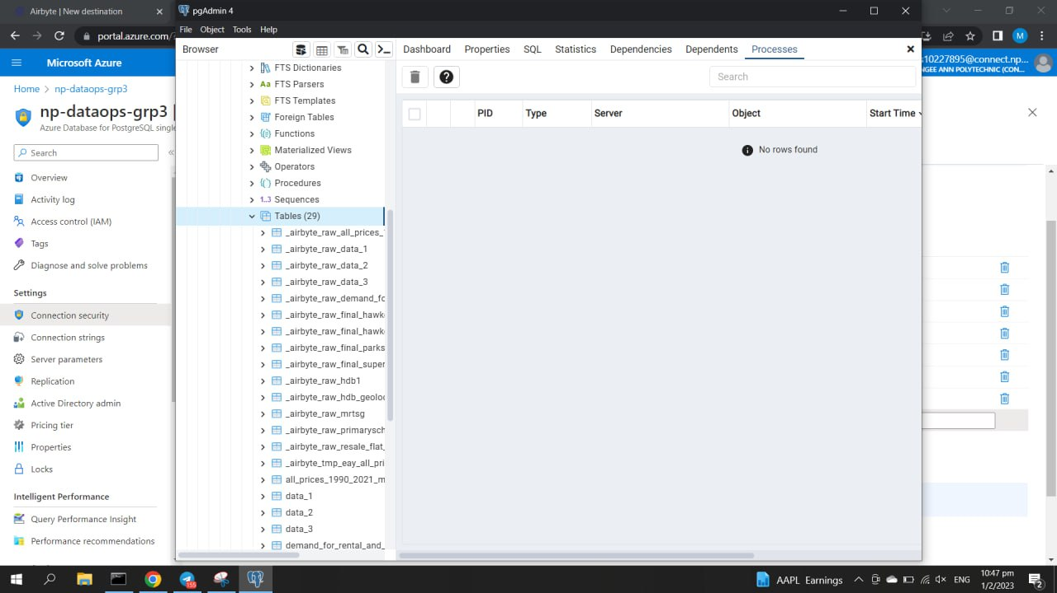

Once the server has been added in PgAdmin 4, I was able to see all of our datasets under

postgres → Schemas → public → Tables.

As the datasets had been successfully added, I used Power BI to use the datasets and conduct Data Analysis on them. I did so by connecting to the **Azure Database for PostgreSQL** in Power BI.

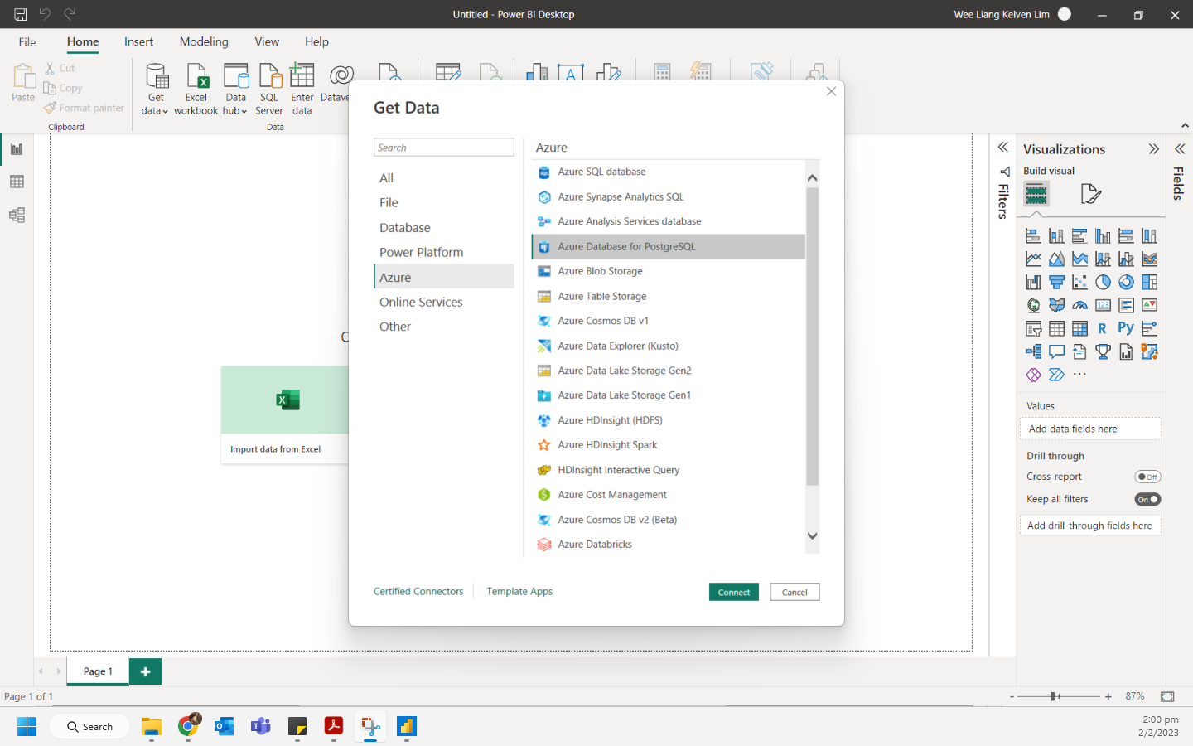

In the **Home** tab, I selected **Get data** → **Azure** → **Azure Database for PostgreSQL**.

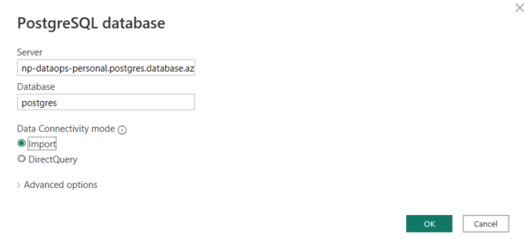

For **Server**, I entered my group’s server name. For **Database**, I entered **postgres** and clicked OK.

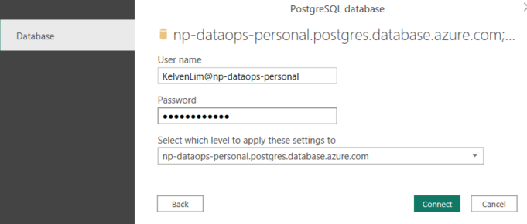

For **Username** and **password**, I enter the admin credentials which is Kelven’s credentials to Connect.

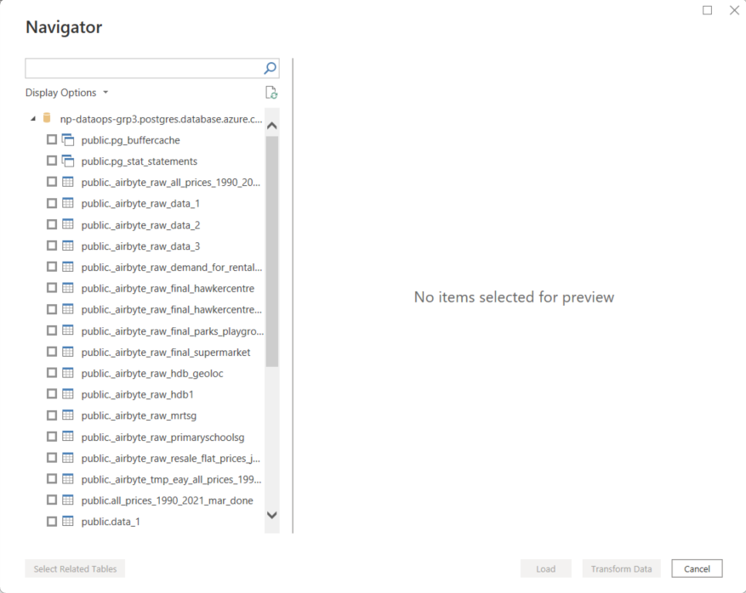

As everything was successful, I was able to see the tables present in the database. I chose the 3 datasets of mine, and proceeded to conduct Data Analysis. As we were only allowed to use one dataset for the dashboard, I used the “primaryschoolsg” dataset of mine to create the visuals.

## **4.2 Chong Xiang**

Since my stakeholder is a realtor, I first went off to source for datasets with useful columns for my stakeholder. Afterwards, I followed the guide to set up Airbyte and Docker containers to push my datasets to the PostgreSQL server, which my group and I have created. This action enhances transparency in the group as it allows every group member to access each other’s dataset. However, while uploading my datasets, I encountered a problem in my Airbyte which does not allow me to proceed further. Thus, I sent my datasets to one of my group members to help upload my datasets onto our group’s PostgreSQL server. This process has delayed our group’s progress for some time as my other groupmates encountered similar issues as what I have experienced. All in all, there were too many errors throughout the entire process of setting up Airbyte and Docker containers and pushing the data to the PostgreSQL server. Despite having a guide, there were unforeseen issues like limited credit usage on Microsoft Azure which is also one of the major issues that my peers and I were facing.

**Setting up individual resource group in Microsoft Azure**

To ensure better team collaboration in this assignment, we were tasked with setting up of Azure database for PostgreSQL in order for each of us in the group to push our individual datasets to the cloud server for the team to access the raw datasets easily. So, firstly, I have created an individual resource group which will be used later to connect to my group’s pgAdmin server.

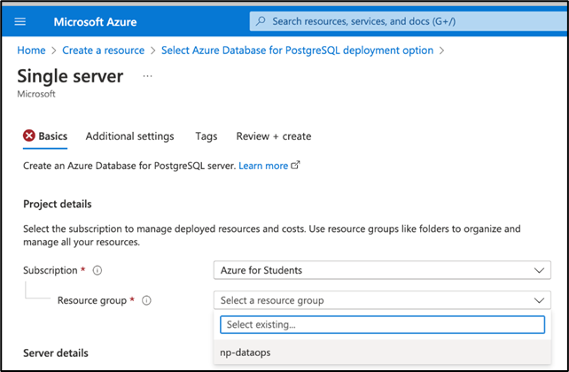

Afterwards, I whitelisted my IP address so that I can have access to the resource group whenever I need to.

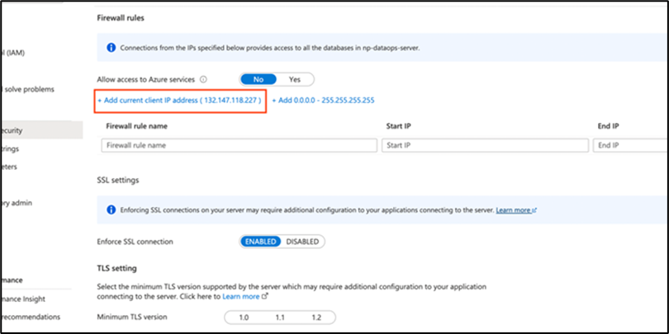

Below screenshot shows that my IP address have been whitelisted and it means that I can access the group server without any connection constraints.

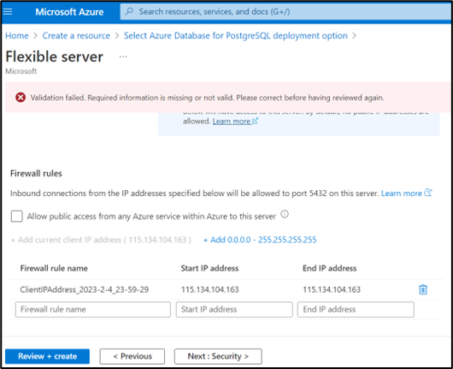

**Getting my datasets ready to be pushed to Airbyte**

Now, I am changing my directory in wsl to my local “Downloads” folder to access my three datasets files, Data_1, Data_2 and Data_3.

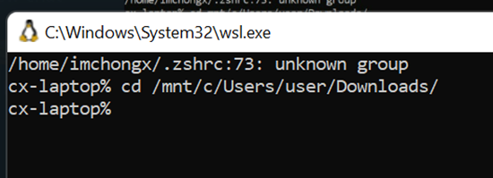

Below are the codes I have used to copy my datasets into the temporary folder in Airbyte.

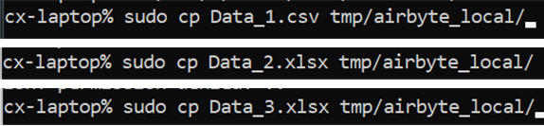

I have used this code below to ensure that my files are being copied into the Airbyte local folder.

ls -al /tmp/airbyte_local/

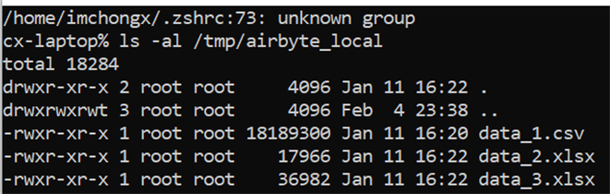

**Setting up Airbyte**

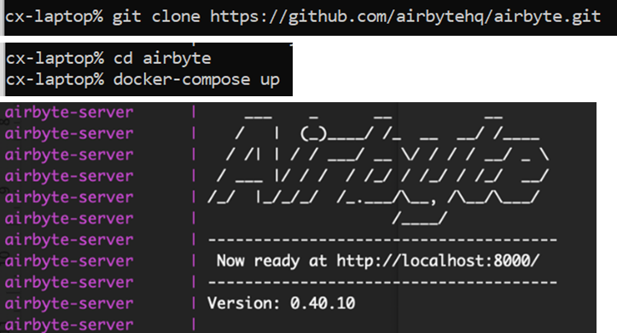

**Creating pipeline to connect data source to pgAdmin**

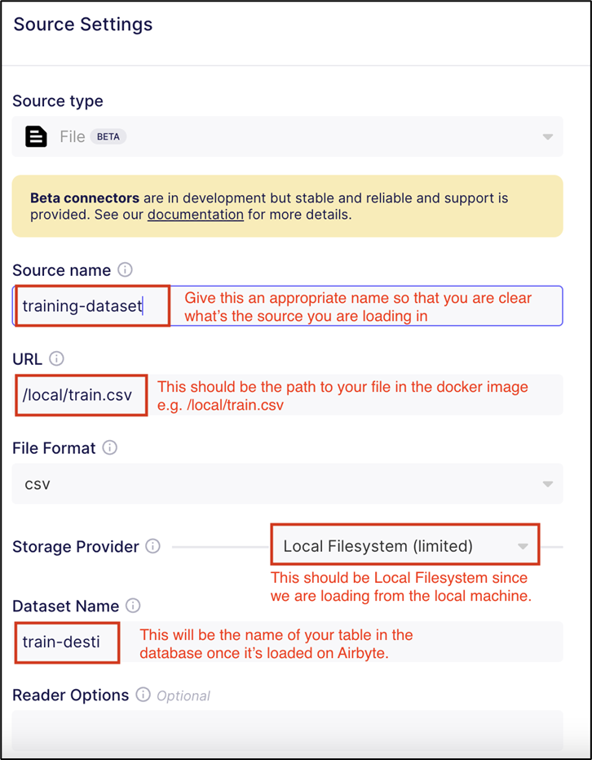

**Data_1**

**Source name:** Data_1

**URL:** /User/users/Downloads/Data_1.csv

**Dataset Name:** Data_1

**Data_2**

**Source name:** Data_2

**URL:** /User/users/Downloads/Data_2.xlsx

**Dataset Name:** Data_2

**Data_3**

**Source name:** Data_3

**URL:** /User/users/Downloads/Data_3.xlsx

**Dataset Name:** Data_3

Above are the details of respective datasets which I have input when setting up the destination.

Following, I set up the destination to my group’s pgAdmin server as input below.

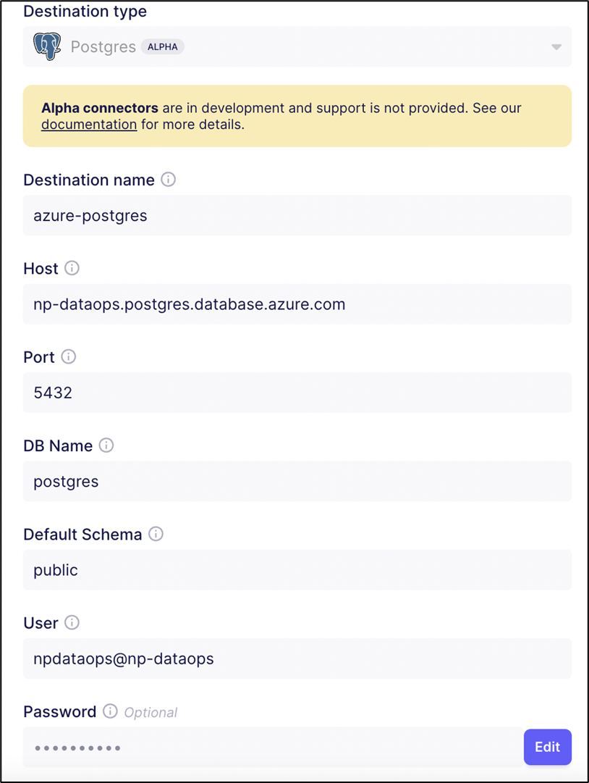

Now that I have finished setting up my data sources and destination in Airbyte, it is ready to be pushed to the group’s server in pgAdmin.

Screenshot below shows both the data sources and destination are set up perfectly.

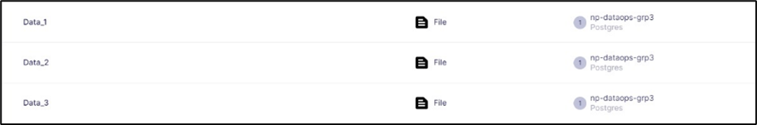

During my exploration in Airbyte, I encountered this unreversible error. I was browsing around the different tabs/features in Airbyte and the error page popped up suddenly. I was unable to change the tabs and perform any actions afterwards even after refreshing the page or reloading Airbyte, I am still stucked at this error page. I encountered the same problem as one of my group members, Kelven who also could not exit this error page no matter what.

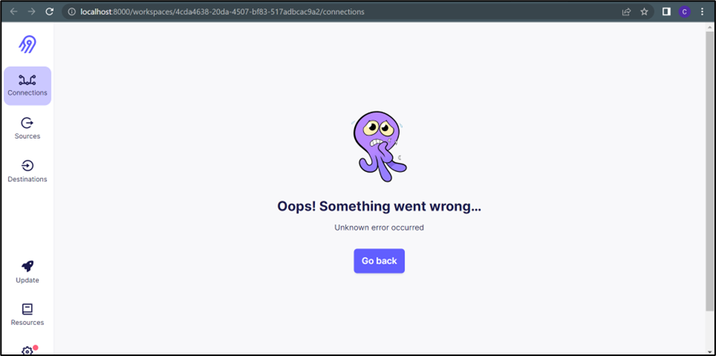

The only viable solution then is to send our datasets to Ambrish, another member of the group, who helped us to push our datasets to pgAdmin. Else not, the group and I could not progress further since we have to upload our respective datasets to the cloud.

**Pushing datasets to pgAdmin**

The image below shows our group’s server in pgAdmin and our respective datasets. With the help from Ambrish, you could see that my datasets are now perfectly uploaded in the group’s server. And finally, this concludes my individual dataops in this assignment.

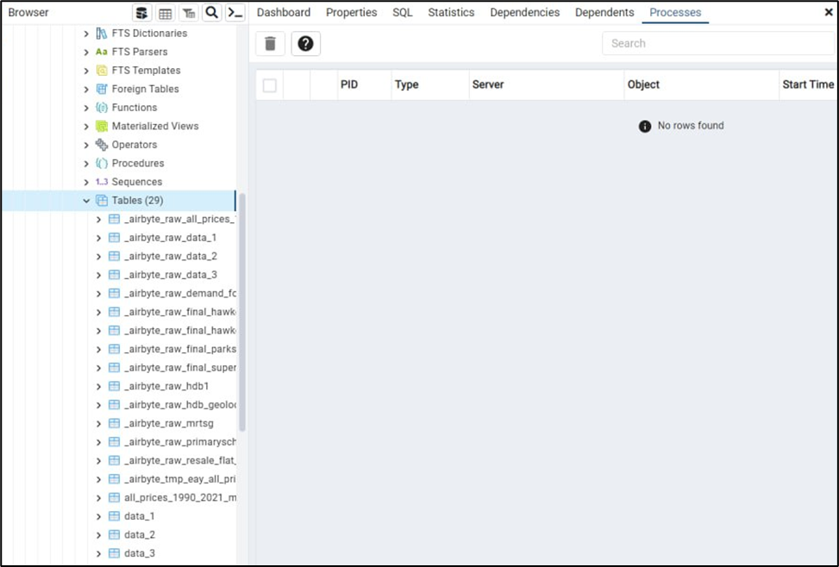

## **4.3 Iman**

There were 2 practicals that we could use, Airbyte or Octavia. The goal of DataOps is to manage data with business goals. I used Airbyte instead of Octavia as I did not have time to meddle with Octavia, and there were many issues with Airbyte throughout the Assignment period. We were a team that would provide Data as a Service (DaaS) to our customers that wanted to buy a flat in Singapore. All of us did practical 7, which was the tutorial on how to set up Airbyte, but only 1 one of us could fully set it up. Docker desktop was needed for practical 7 and it made both my personal computer and laptop perform sluggishly, causing both devices to stutter and lag. When I first set up Airbyte, it crashed, did not want to start at times and gave me an error. Even if it did start, it would crash randomly, stating that there was an unexpected error. I did not attempt practical 8’s tutorial, Octavia, as I did not have time for it and the teacher said that if we could get either practicals 7 or 8 to work, then we were good to go.

Dashboards were created by each of us using Power BI to display our visualisations for our own user stories. My user story was about HDB on what the remaining lease was for a flat in a certain area. We all have 3 datasets each. I deleted some columns in all of my datasets as some were impractical or meaningless for my user story.

We created our website using Weebly to showcase our visualisations, team members and explanations of the visualisations. There were many issues throughout the assignment, like time constraints, procrastination and problems with tasks in sprints which were all solved the following day.

To start off, I went to Microsoft Azure’s Portal to create my own database.

From here, I press on the “Create a resource” button under Azure services.

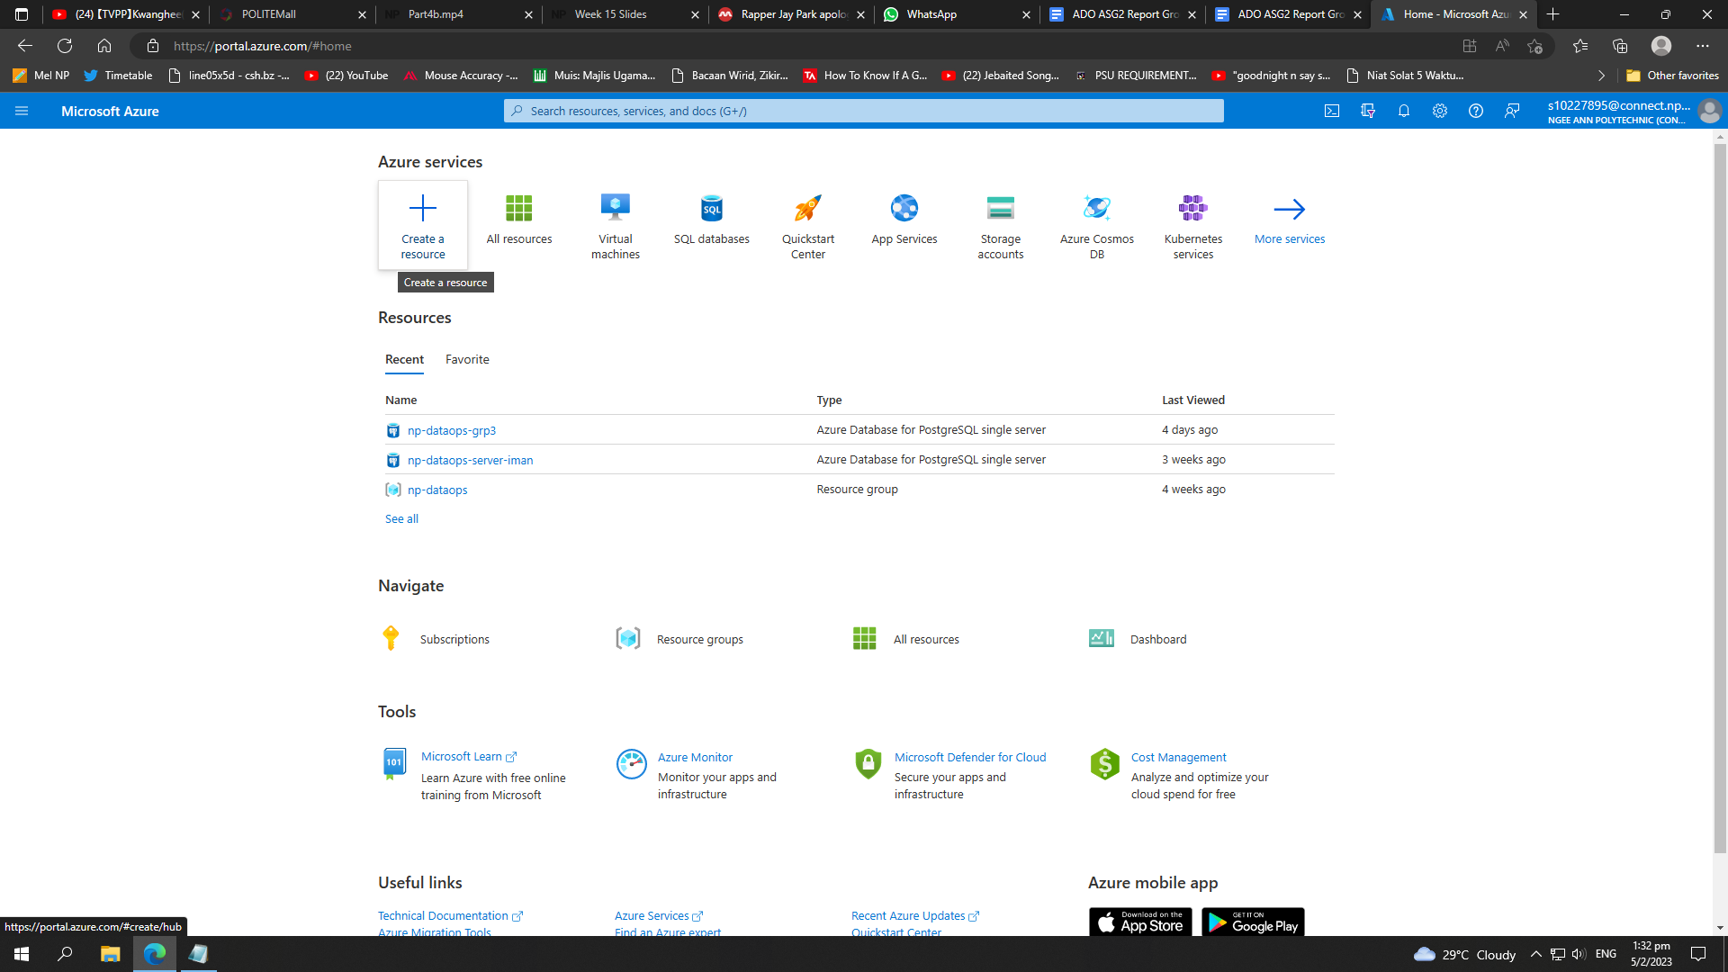

Afterwards, the page will change to the “Create a resource” page and on the rights side, press “Database”.

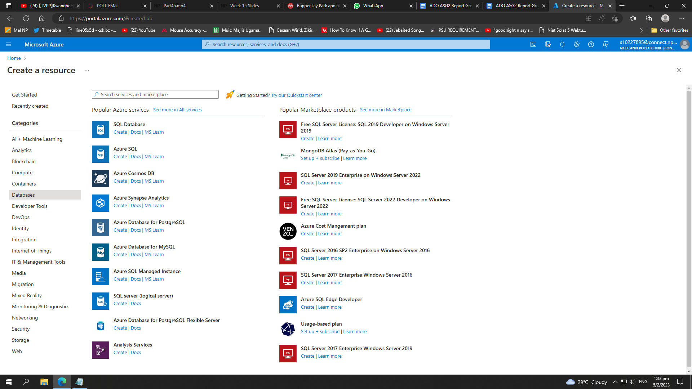

There will be all sorts of different databases shown. For this Assignment, we will be using Azure Database for PostgreSQL. Click on “Create” under Azure Database for PostgreSQL

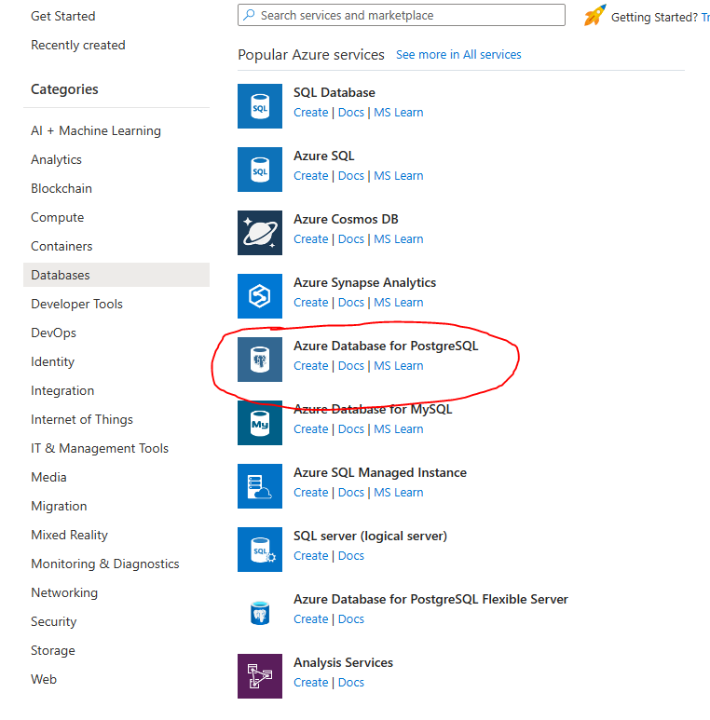

Once pressed, under Azure Database for PostgreSQL, change the resource type to “Single server”. Press “Create” once changed.

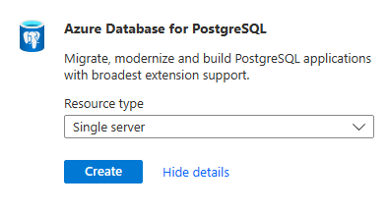

Once created, the page will change to where you can configure the details of the single server.

For Resource group, I changed it to “np-dataops”.

Server name, I changed it to “np-dataops-iman” as it was my own personal database.

Then I changed the server settings under the blue coloured hyperlink, “Configure server”, where it will lead you to another page.

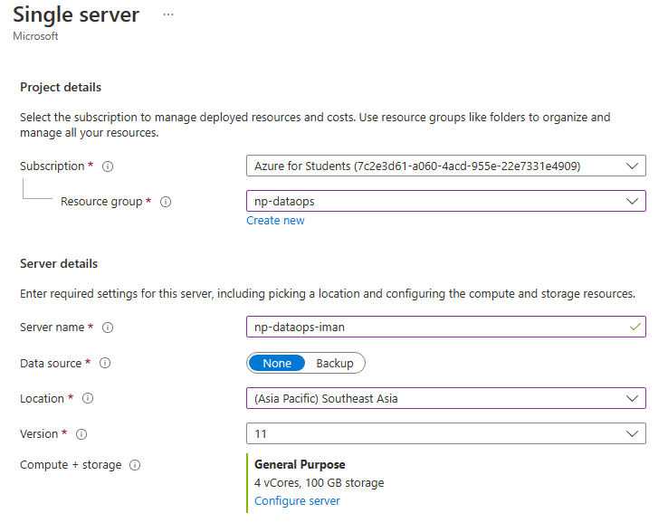

Under the “Basic” tab, **vCore** is changed to **1 vCore** and **Storage** is changed to **10GB.**

Once done, press on the “OK” button below.

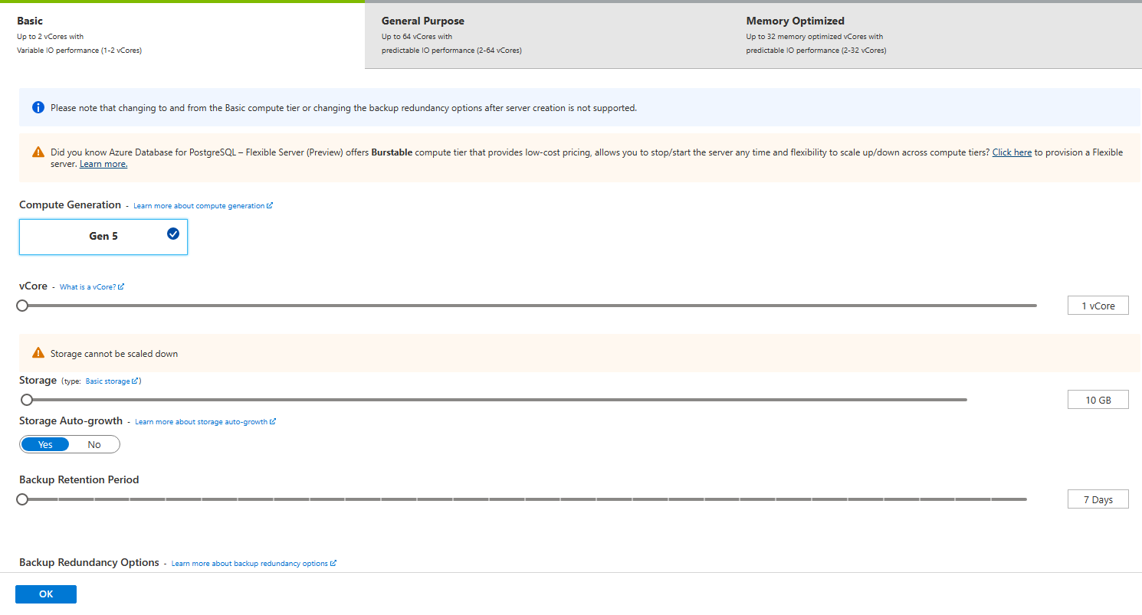

Next, I set my admin username to “Iman07, and with the password that I set. Press “Review + Create” once done.

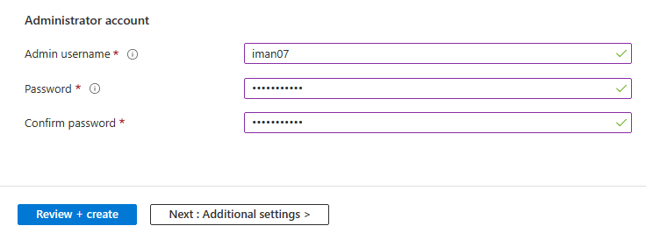

This will show the summary of the single server that we have just created. Press “Create” to continue.

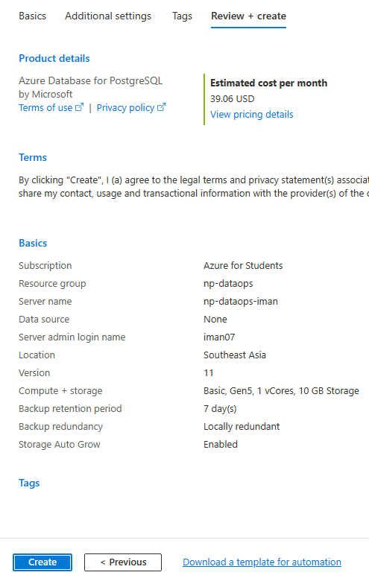

The page will then show that deployment is in progress. This should take 1-2 minutes.

There will be a green tick if the deployment is completed.

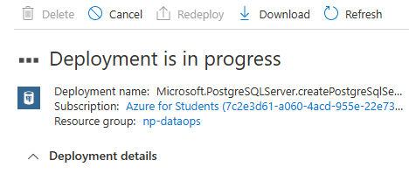

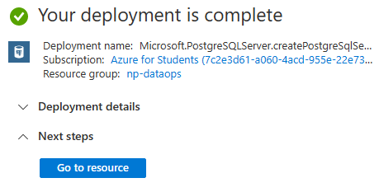

Once deployment is completed, press on “Go to resource” and press on the hyperlink “Enabled” beside SSL enforce status.

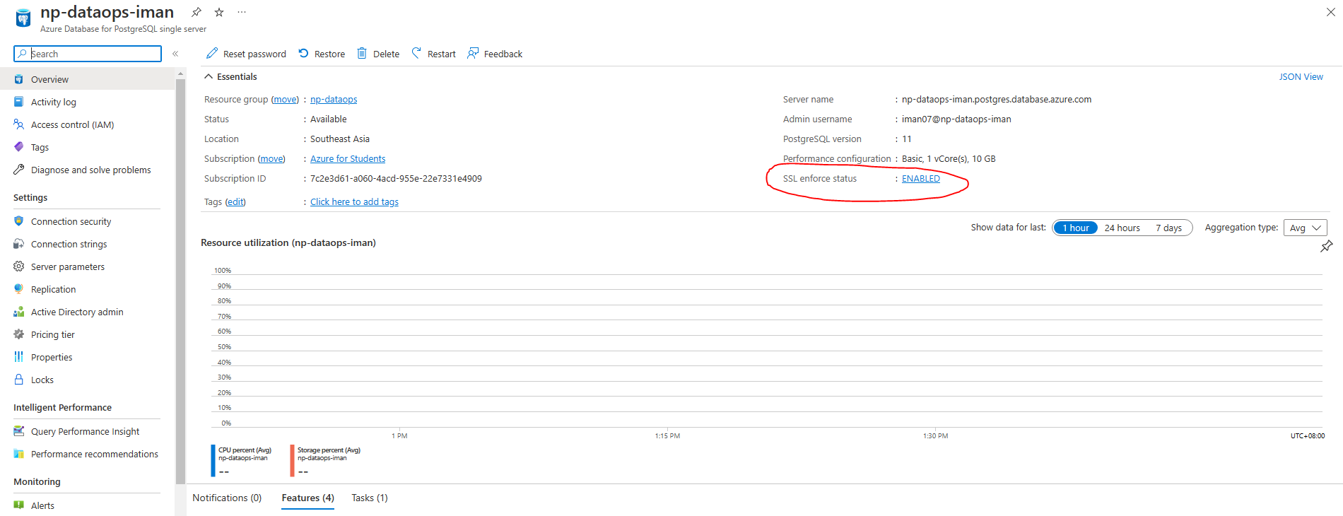

Press on +Add current IP address (000.00.00.000). The IP address will be different that the one in the image below. As for mine, it’s 115.66.17.247.

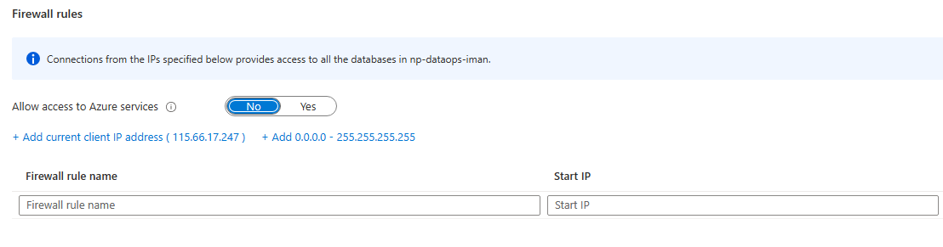

Once added, press “Save” on the top left corner.

As for when we are in Ngee Ann Polytechnic, in buildings 34, 31, and 27, we have to use the following IP address for both Start IP and End IP.

153.20.0.0 (Start IP)

153.20.255.255 (End IP)

These IPs have been whitelisted when using the wifi, NPWirelessX, in the buildings mentioned.

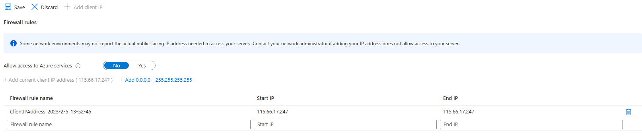



Following tutorial 7’s on setting up Airbyte, I was to set up Airbyte on my local machine through Docker container, set up the connector and destination in Airbyte and create my own Airbyte pipeline that connects the connector and destination. As I have already completed tutorial 7, I will show the DataOps part, where I show how I uploaded my datasets into the database.

The first step was to start up Docker desktop, which I have already installed onto my local machine during the first week of the module. The process to install Docker desktop can be done by searching up Docker desktop, going to Docker’s official website and downloading the software.

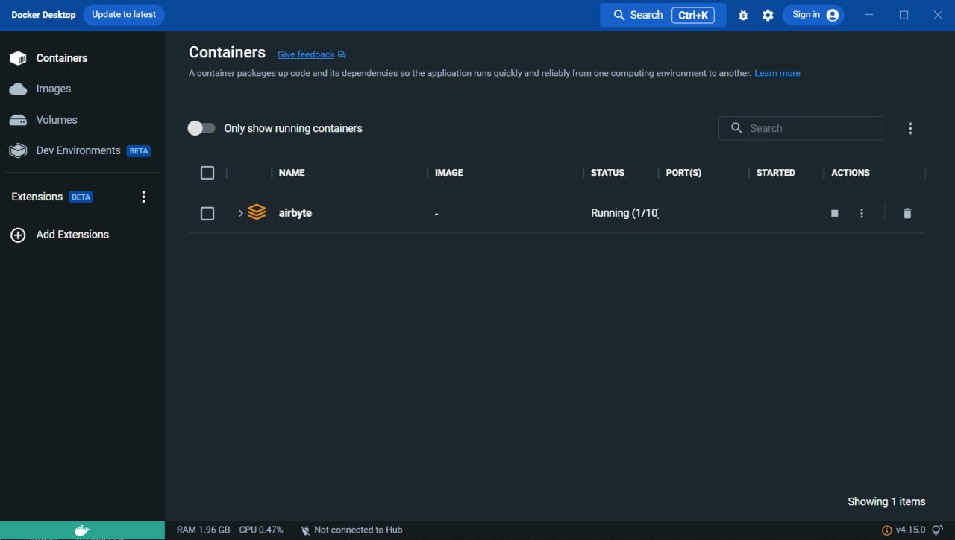

Once Docker desktop started, I had to wait a few minutes for it to fully load.

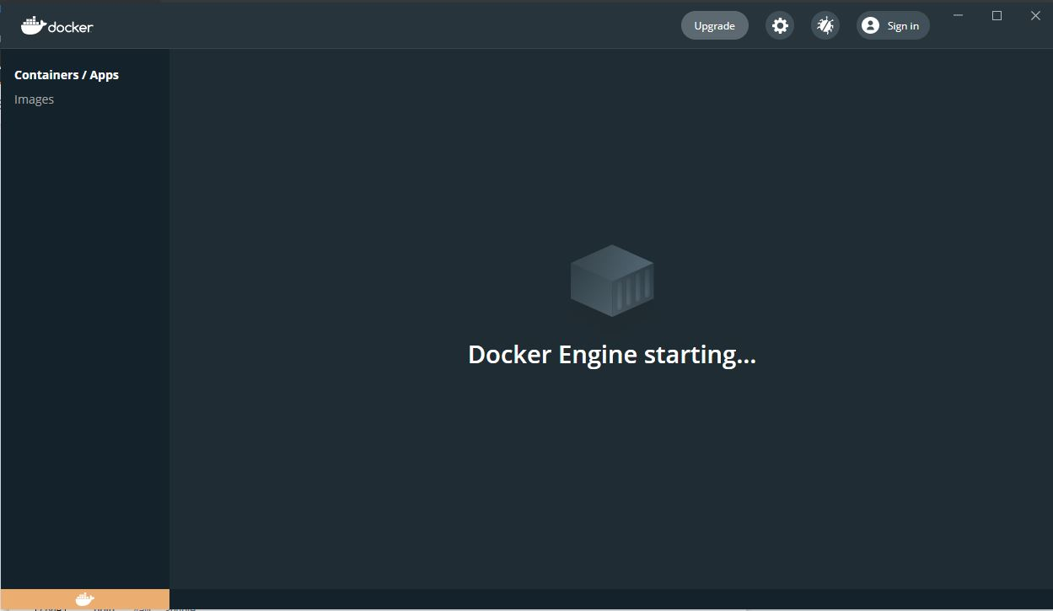

After Docker desktop has started, I then open up my WSL, Windows Subsystem for Linux, which was installed in the first week of the module. This was done by opening up the command prompt as administrator and typing in “wsl – install” which will then install WSL onto my Windows machine.

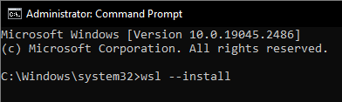

Once WSL is open, I then proceeded to install Airbyte open-source onto my machine by typing in the following commands into the WSL terminal.

First command



“git clone” is a command where it will clone an existing repository into a new directory.

Second command

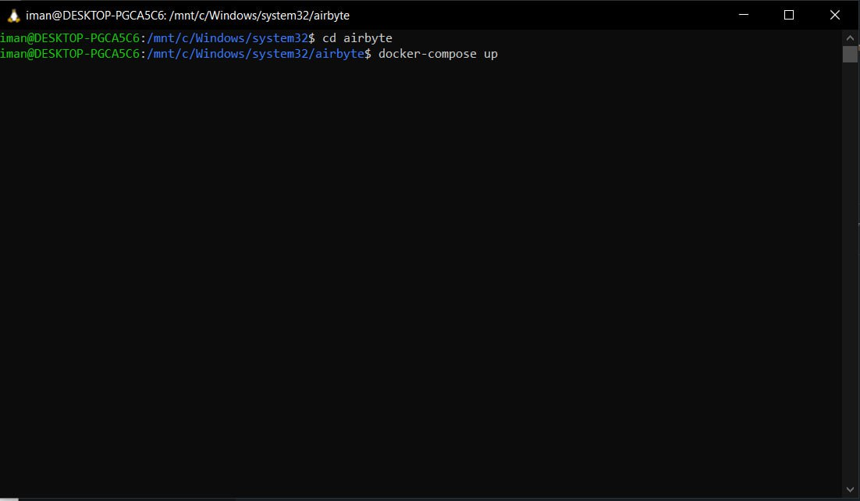

“cd”, change directory, is where it changes the current directory into the specified directory, in this case, it is “airbyte”.

Third command



“docker-compose up” is a command where it starts up Airbyte and loads whatever is necessary for Airbyte open-source.

Once the third command has been executed, there will be bunch of texts where it’s loading up Airbyte.



When the loading is finished, I should be seeing the Airbyte logo and below it will show “Now ready at <http://localhost:8000>”. I will then be able to enter Airbyte by entering “<http://localhost:8000>” on my browser.



When entering Airbyte on my browser, a small box will appear, prompting for my Username and Password. I simply type in the credentials.



Once my credentials have been entered, I will be prompted to enter my email, a series of check buttons for data collection which are optional and a “Continue” button where I simply press the button to continue onto Airbyte’s main page.



This is the welcome page for Airbyte.



For the dataset, I have to copy the file into /tmp/airbyte_local

To do this, I simply open up WSL as administrator, cd into the folder where I stored the file, copied the file by typing “cd *filename* /tmp/airbyte_local”

Now that my Airbyte is up and running, I will now add my datasets. To upload my dataset, I have to set up the source in the source side tab where it will upload the dataset. The source type will be a file and the file format will be an excel file, or a .csv file. The URL will be where the file is stored in and in this case, the file stored in /tmp/airbyte_local





Once the source has been created, it would look something like this.



As for destination, it will be added by going onto the Destination side tab. The destination type would be Postgres as the database is under Postgres. Destination name is “np-dataops-grp3”, Host is “np-dataops-grp3.postgres.database.azure.com”, Port 5432, DB Name “postgres”, User is KelvenLim@np-dataops-grp3 and the password for Kelven’s account. SSL connection is required so it is set to “Allow”.

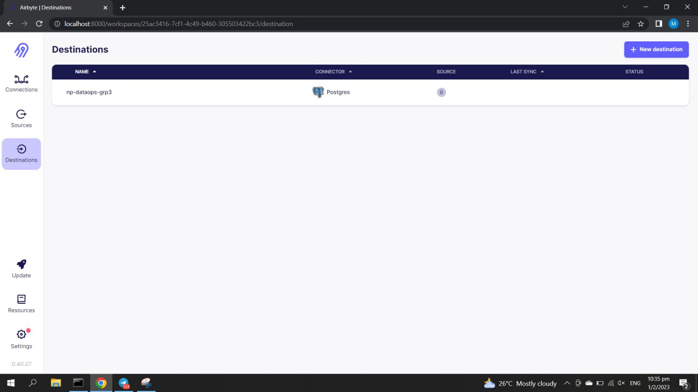

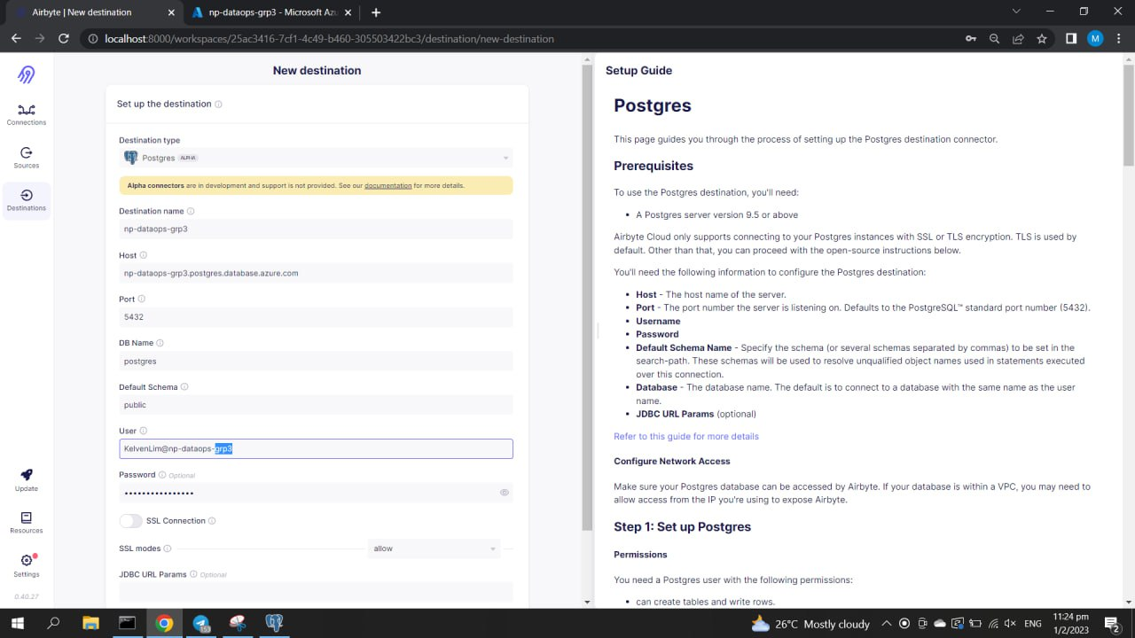

Once all connections have passed, the destination will come up like in the picture below.



Unfortunately, due to some errors with my Airbyte, it was not working the next day after setting up the destination. It showed the following error in the image below. I did a factory reset to redo Airbyte on a fresh new Windows but to no avail.

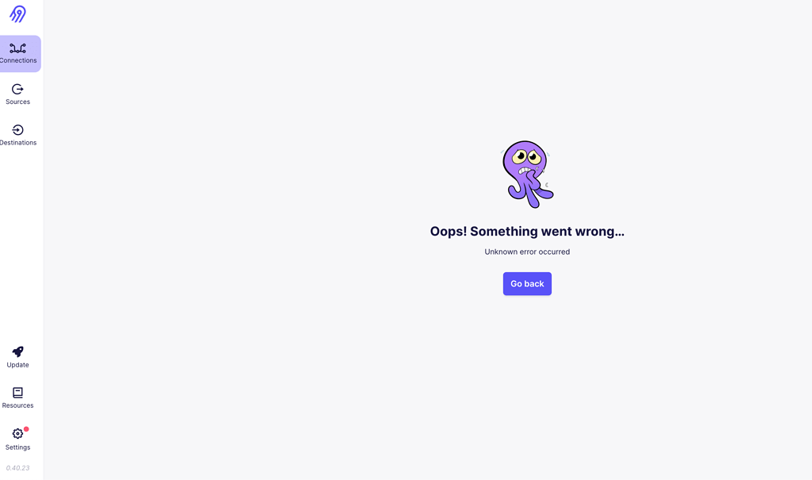

Fortunately, my teammate, Ambrish, was able to help me upload my data sets onto the database. I was able to view my datasets on PgAdmin4, a software where we can manage our postgre servers. The first step is to connect to the database in PgAdmin4 by registering a server.



The name of the server will be “np-dataops-grp3”



For the host name, port, database name, username, and password, are the same credentials as when setting up the destination in Airbyte.



Once connected, it will show that the server has been added. If it shows an error saying that “SSL connection is required”, I will then have to add my machine’s IP address into the database to whitelist it so that I can access the database. The picture below shows that I have already added my IP address into the database.

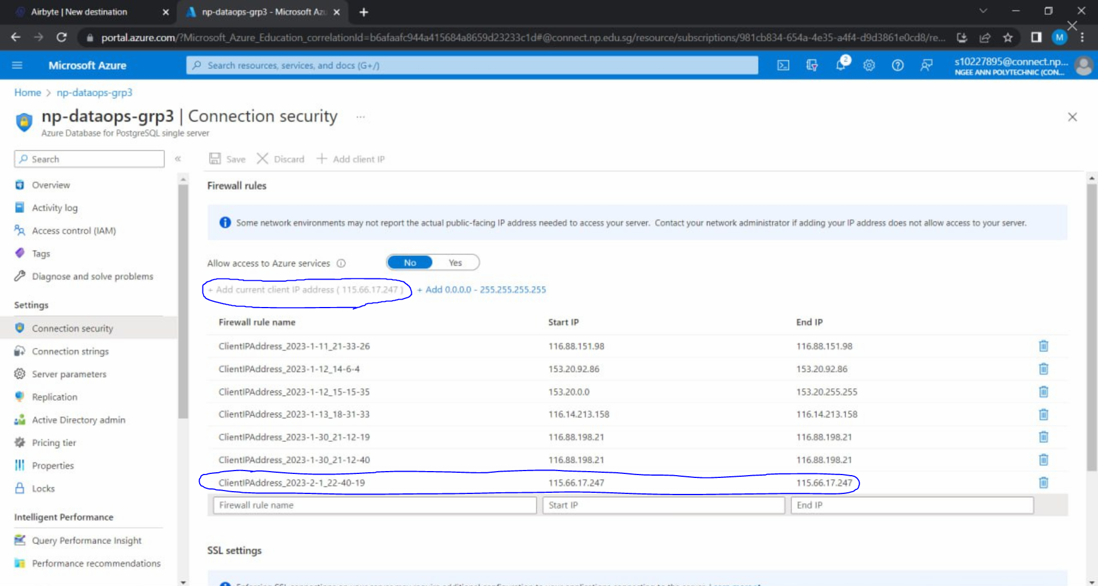

Once the server has been added in PgAdmin4, I will be able to see my datasets under

postgres > Schemas > public > Tables



## **4.4 Kelven**

During our Sprint 1 planning, we ideated user stories and tasks that can answer them. We ideated 3 users, parents, realtors, and HDB because we felt they need housing data more than other users.

During Sprint 1, we needed to source data and create a Wix website. However, I was only able to source data. My initial user story was “As a parent, I want to know the nearest hawker centres, *shopping malls*, and parks near my home”. I could not find datasets with sufficient information about shopping malls, thus I changed shopping malls to supermarkets. When sourcing for datasets about park locations, I could only find one dataset that combines park locations and playground locations. Since parks and playgrounds came together, I decided to use both of them.

The 3 datasets that I have chosen are:

* hawker-centres-kml.csv
* parks_playgrounds.csv
* supermarket.csv

Sprint 2 focused on data cleansing. During this sprint, I utilised Jupyter Notebook to clean my data. In particular, to remove any null values and redundant columns. The codes used to clean the data are shown below.

|  |
| --- |
| import pandas as pd  hawkercentre = pd.read_csv('hawker-centres-kml.csv') new_hawkercentre = hawkercentre[['Name', 'LATITUDE', 'LONGITUDE', 'description', 'STATUS', 'NO_OF_FOOD_STALLS', 'REGION', 'NO_OF_MARKET_STALLS']] final_hawkercentre = new_hawkercentre[new_hawkercentre['LATITUDE'] > 0] final_hawkercentre.to_csv('final_hawkercentre_v2.csv', index = False, sep = ',', encoding = 'utf-8')  parks_playgrounds = pd.read_csv('parks_playgrounds.csv') final_parks_playgrounds = parks_playgrounds final_parks_playgrounds.to_csv('final_parks_playgrounds.csv', index = False, sep = ',', encoding = 'utf-8')  supermarket = pd.read_csv('supermarket.csv') new_supermarket = supermarket.drop(columns = 'STR_NAME') final_supermarket = new_supermarket final_supermarket.to_csv('final_supermarket.csv', index = False, sep = ',', encoding = 'utf-8') |

However, looking back, since this module focuses on ELT rather than ETL, I should have uploaded my datasets to the database before cleaning them.

Sprint 3 focused on pipelining the data to the Azure database. When uploading my datasets to the database, I followed week 7’s Airbyte tutorial. During week 1, we were tasked with downloading a multitude of softwares like WSL, Ubuntu, Oh-my-zsh, Anaconda, and Docker Desktop. The installation guide for all of these softwares can be found through this link <https://github.com/jair-zhou/ADO-installation/blob/main/Windows.md>. Additionally, we needed to download PostgreSQL and PgAdmin 4 as well. The installation guide to both of them can be found in this LinkedIn Learning video <https://www.linkedin.com/learning/postgresql-essential-training/download-and-install-postgresql?autoplay=true&resume=false&u=42538748>.

Once everything is installed, an Azure database will be created. Before uploading my datasets to the group database, I first tested the process on a personal database.

Open the hamburger menu on the top left and select **Create a resource**.



Select **Databases** from the New page and select **Azure Database for PostgreSQL** from the Databases page and click **Create**.



Choose the **Single server** option.



You will be brought to this page to configure your PostgreSQL Server.



Under **Resource Group**, create a new name for your resource group. For my group’s database, I used **np-dataops-personal**.



Under **Server Name**,I used **np-dataops-personal**. Under **Compute + Storage**, click on **Configure** server.



You will be brought to a page that looks like the one below to configure your server’s compute and storage.



To ensure cost efficiency, we will choose the Basic option on the top tabs. Move sliders to get the following

For the **vCore**, keep it to **1x** vCore.

For the **storage**, keep it at **10x** GB.



You should be able to see the price summary on the right. It should be somewhere close to the cost that you see above. For the other options, leave as it is. Click on the Ok button at the bottom left and you will return to the previous page.



For **Admin username**, I used **KelvenLim@np-dataops-personal**. For **Password**, I used **24A675223b04.**

You will be asked to review the configurations before you create the server. After reviewing, click on **Create** to proceed and just wait.

Once the server is ready, click on the **Go to resource**. This will bring you to the credentials page for your Azure PostgreSQL database server.



Next, click on the hyperlink on **SSL enforce status**. This will bring you to the page below where you can configure the Connection Security. Then click on this hyperlink to add your current client IP address to be whitelisted. This will allow your machine’s IP address to be allowed connection to the Azure PostgreSQL database server.



After creating the group database, open up WSL as administrator and install Airbyte using the following commands into the WSL terminal.







Once “docker-compose up” has been executed, text will appear while Airbyte is loading



After a few minutes, the windows will show Airbyte logo and the message “Now ready at <http://localhost:8000>”.



After entering the link, enter “airbyte” for the Username and “password” for the Password.



If it is your first time using Airbyte, you will be prompted to enter your email and select optional fields. Click “Continue” when done



This is the welcome page for Airbyte.



After opening Airbyte, the csv files have to be copied into a temporary folder.

First, change directory to where the file is stored using cd /path/to/<ANOTHER_FOLDER>

(e.g. cd /Users/Kelve/Downloads)

Secondly, copy the file into the temporary folder using sudo cp file_name.csv /tmp/airbyte_local

To pipeline the dataset to the database using Airbyte, a **Connection** has to be made between a **Source** and **Destination**.

To create a Source, in the **Sources** tab, click on **+ New Source**.



Select **File** for **Source Type.** For **Source name**, it is the name of the source when you see it in Airbyte. Enter the csv file name for easy reference. For **URL,** enter where the file is stored. In and in this case, the file stored in/tmp/airbyte_local. Lastly for **Dataset name**, it is the table name in the database once it is loaded. Enter the csv file name for easy reference. Once the form is completed, click **Set up source** to test the connection. If there’s an error, you cannot proceed to the next step.



Once the source has been created, it would look something like this.



This step is repeated for the other 2 datasets.

To create a destination, in the **Destinations** tab, click on **+ New Destination**.



Select **Postgres** as the **Destination type**. The **Destination name** is the name of the destination when you see it in Airbyte. Enter “np-dataops-personal” for easy reference. For **Host**, enter the server name, **np-dataops-personal.postgres.database.azure.com**. For **Port**, enter **5432**. For **DB Name**, enter **postgres**. For **User** enter the admin username, **KelvenLim@np-dataops-personal**. For **Password**, enter the admin password **24A675223b04**. Allow **SSL connection**.



If it is successful, a new destination should be created.



Now that the source and destination are set up, a new connection can be made between the sources and destination.

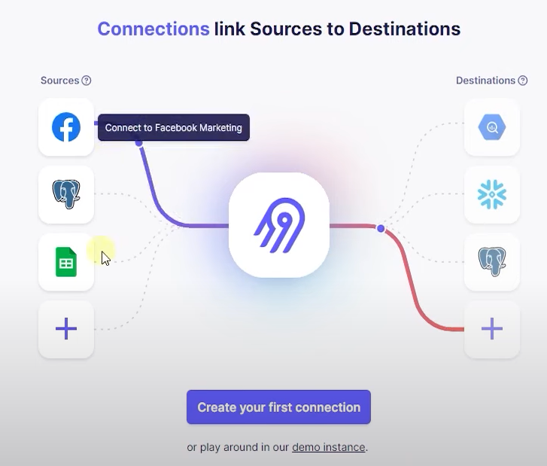

To create a connection, in the **Connections** tab, click on **Create your first connection**.

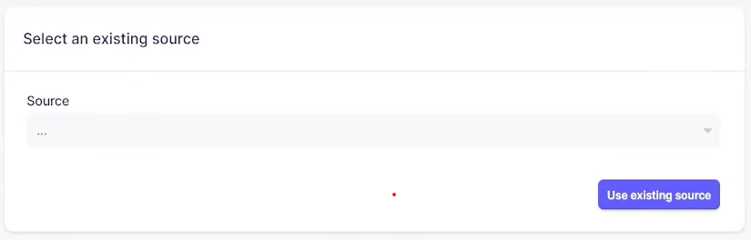

Next, in the **Select an existing source** box, click on the dropdown menu and select a source created previously and click **Use existing source** when done.

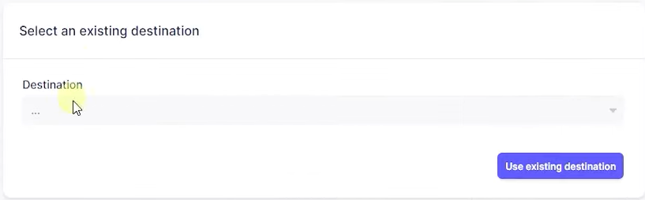

Next, in the **Select an existing destination** box, click on the dropdown menu and select a destination created previously and click **Use existing destination** when done.



After selecting an existing source and destination, name the connection or leave it as the default name. For the other fields, you can leave them as is.

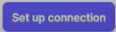

When done, click **Set up connection**.

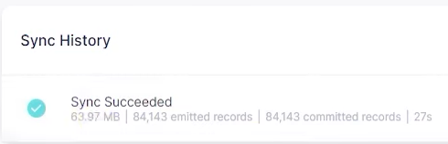

If everything is correct, the sync should succeed.

Repeat the steps for the other 2 sources.

After creating the connections, I went to PgAdmin 4 to test the connection.



Once PgAdmin 4 is loaded, right-click on **Servers**, select **Register**, then **Server…**.



The name of the server will be “np-dataops-personal”



Go to the **Connection** tab, the host name, port, database name, username, and password, are the same credentials as when setting up the destination in Airbyte.

Host: np-dataops-personal.postgres.database.azure.com

Port: 5432

Maintenance database: postgres

Username: KelvenLim@np-dataops-personal

Password: 24A675223b04.



Once the server has been added in PgAdmin 4, I will be able to see my datasets under

postgres → Schemas → public → Tables.

Next, I opened Power BI and attempted connecting to the Azure database.



In the **Home** tab, select **Get data** → **Azure** → **Azure Database for PostgreSQL**.



For **Server**, enter the server name. For **Database**, enter **postgres**. Click OK.



For **User name**, enter the admin username. For **password**, enter the admin password. Click Connect.



If everything is successful, you should be able to see the tables loaded into the database.

At this point, since everything was successful, I created a group database for all the members to connect. The steps used to create the group database is the same as the ones used for the personal database. I created a **new resource** called **np-dataops-grp3** and named the **database** similarly.

However, when I attempted to connect to the group database, the Airbyte UI crashed. I had tried restarting my laptop, updating Airbyte, and reinstalling Airbyte, but to no avail.



Fortunately, my teammate, Ambrish, had a working Airbyte and was able to help upload my datasets into the database. The steps used to connect my datasets to the group database is the same as the ones used previously. I was able to view my datasets from the group database on PgAdmin 4 and Power BI using the same steps as used before.

Before receiving help from my groupmate, I also attempted to set up a connection using week 8’s tutorial on Octavia CLI. However, when setting up the connection, I ran into an error even though I followed the instructions exactly.

After creating the connections, I proceeded with creating the visualisations for my dashboard. Since we could only use 1 dataset, I used the one about hawker centrs since it had the most number of columns. I also could not merge my 3 datasets together as that would create many null values.

## **5. DataOps Scalability**

Since all our data sources are static data, our models are not scalable.

Assuming our data was from a live connection, it would not be scalable. Our team used the Airbyte interface shown in week 7's practical. If we connected the datasets to the database using Octavia as shown in week 8’s practical, the process could be automated as it is a command line interface.

Also, some of our data had many redundant columns. If more datasets with different columns are added, this column removal process cannot be automated as it requires human interaction to determine what is needed.

Our goal is to help our audience determine the best house to buy. This is done by understanding their needs and concerns, and AI cannot replicate this.

## **6. Visualisation**

## **6.1 Ambrish**

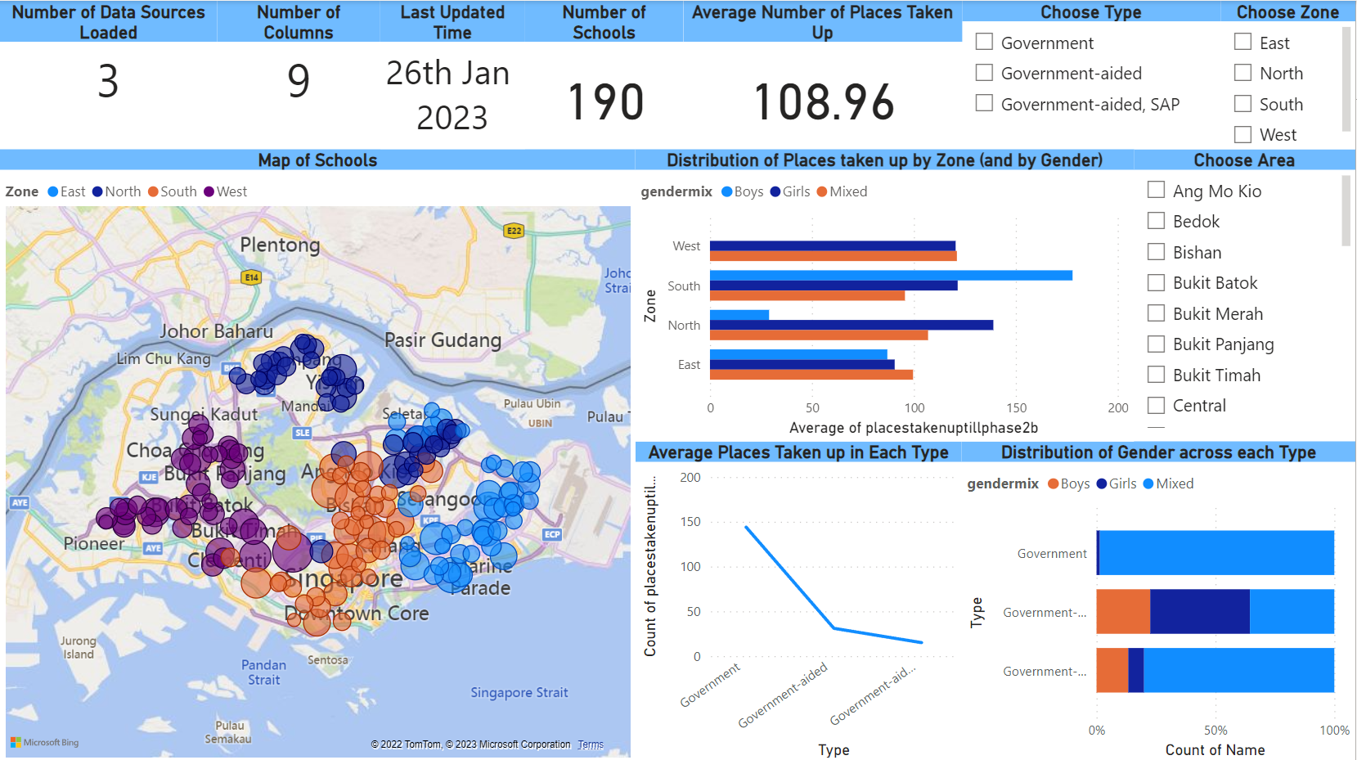

The above image showcases a Dashboard made using Microsoft Power BI. It comprises of 4 visuals alongside 3 slicers. The 4 visuals are as follows:

* Map of Schools
* Distribution of Places taken up by Zone (And by Gender)
* Average places are taken up in each Type
* Distribution of Gender across each Type

Although there are 3 datasets that have been compiled in total, this dashboard only focuses on one of them which is the primaryschoolsg.csv dataset. It contains 9 columns and was last updated on 26th Jan 2023.

As seen from the dashboard, the main target audience of this dashboard is Families. It can also be seen that there is a total of 190 primary schools in Singapore, with each of them gaining 109 pupils on average up until Phase 2B in 2022. There are also 3 types of schools which are Government, Government-Aided and Government-Aided, SAP. We can also see that there is a total of 4 zones which are North, South, East and West respectively.

This next segment will feature more in-depth explanations of each visual that is present in the dashboard.

**Map of Schools**

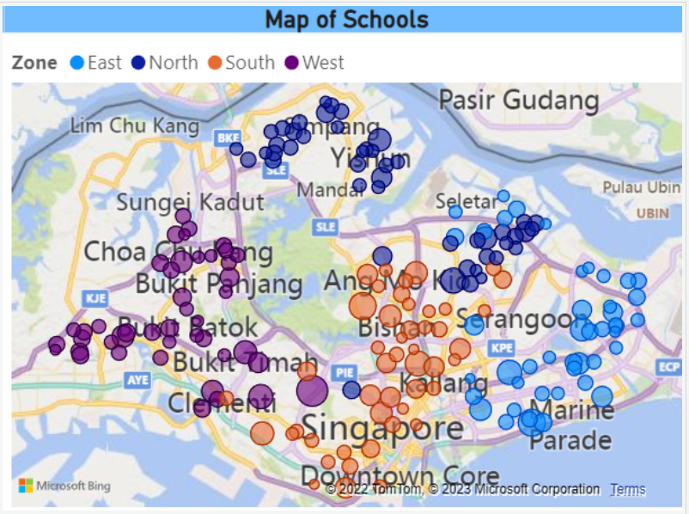

The final visual depicts a map of Singapore with the distinct location of each primary school in Singapore marked out. They have also been further grouped up by colour according to the Zone that they are part of. Each location also varies in bubble size according to the number of places taken up by each school.

**Distribution of Places taken up by Zone (And by Gender)**

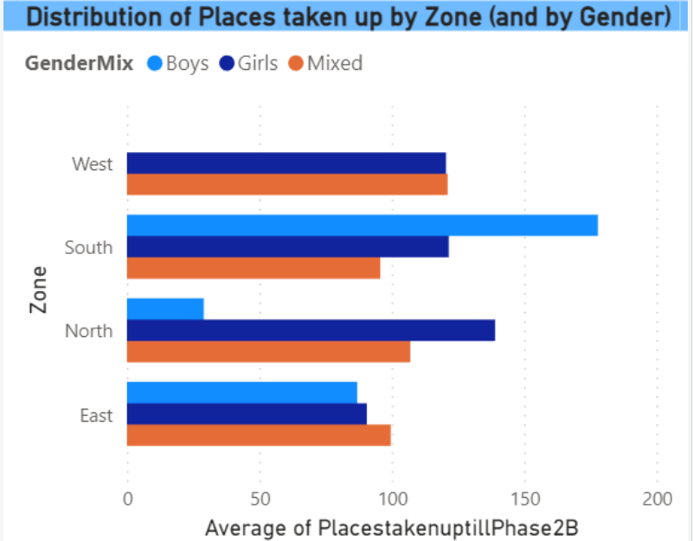

​This clustered bar chart highlights the distribution of places taken up across each Zone and further separated according to Gender. It can be inferred from this visual that the mixed gender schools in the West Zone has the most number of places taken up. It also has no Boys schools as seen beforehand in the 1st visual. The Boys School in the South Zone has the most number of places taken up with an average of around 180 which is nearly 6 times that of the boys schools in the North and nearly 2 times that of the boys schools in the East. Moreover, the Girls Schools in the North have the most number of places taken up with around 145.

**Average Places taken up in each Zone**

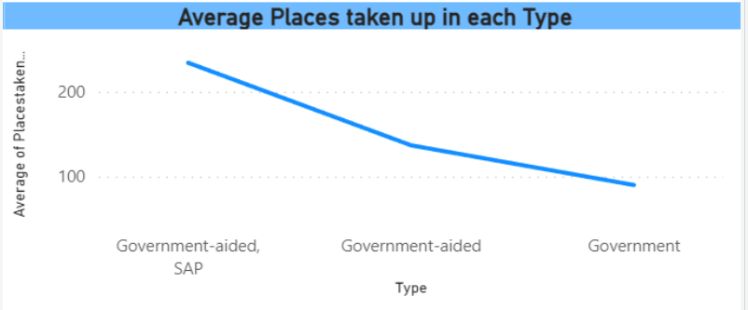

​This line chart showcases the Average number of places taken up across each zone up until Phase 2b using a Line Chart. It can be seen that on average, schools of type Government-Aided, SAP has the highest number of places taken up with around 232 places while Government Schools have the least number of places taken up with around 96. One interesting fact is that Government-Aided, SAP schools have over twice the amount of places taken up as compared to Government Schools.

**Distribution of Gender Across Each Type of School**

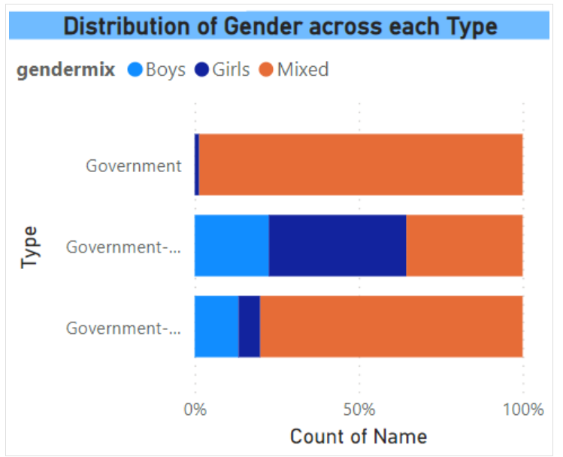

​This 100% stacked bar chart highlights the average distribution of gender in each type of school through the means of a 100% stacked bar chart. The light blue bar represents Boys, dark blue represents Girls and Orange represents mixed.

It can be inferred from this chart that Government and Government-Aided, SAP schools are generally more mixed as opposed to having just boys or girls.

It can also be seen that the Government-Aided Schools has the highest proportion of girls only schools while also having the least amount of mixed gender schools. The Government has the most number of mixed gender schools while also having no boys schools at all which is interesting.

## **6.2 Chong Xiang**

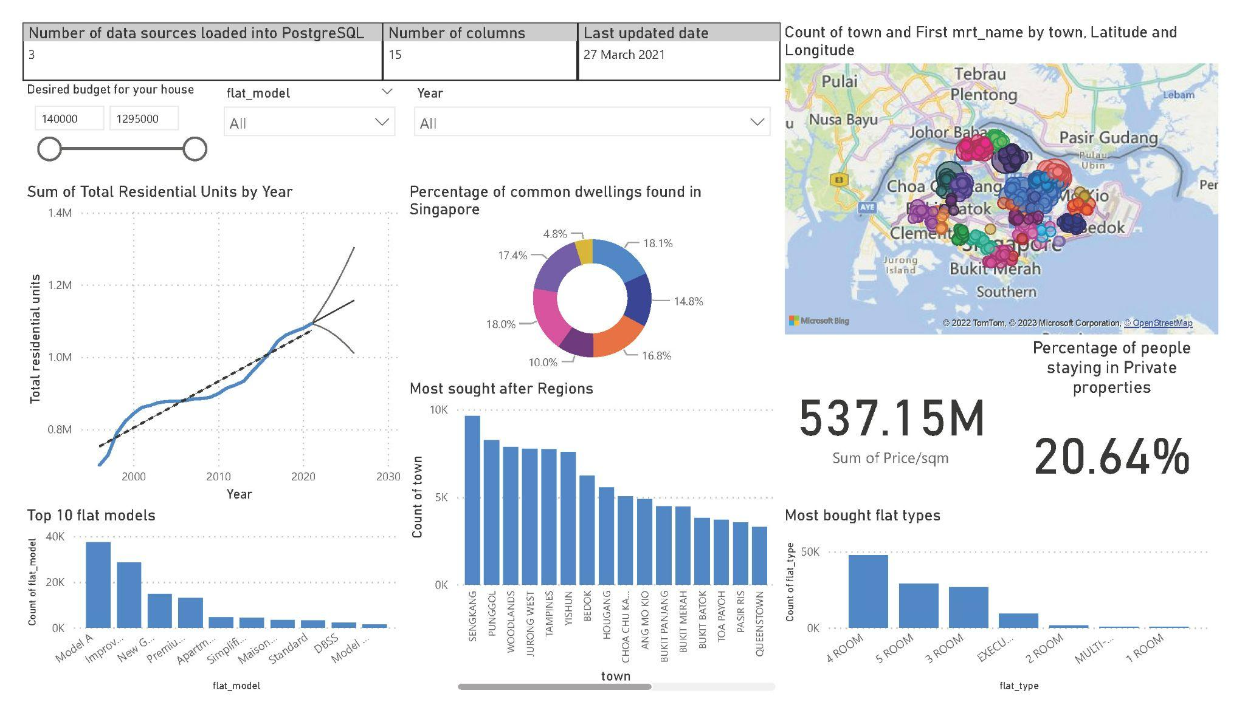

​The above image showcases a Dashboard made using Microsoft Power BI. It comprises 8 visuals alongside 3 slicers.

The 8 visuals are as follows:

* Sum of Residential Units by Year
* Percentage of common dwellings found in Singapore
* Top 10 flat models
* Most sought-after Regions
* Map chart showing the count of flats sold across Singapore
* QnA visual showing the price per square metre
* Card which shows the percentage of people living in private properties
* Most bought flat types

​

Most of the visuals as shown in the dashboard are created from Data_1. Despite this, this dashboard includes visuals created from all three datasets which are sourced from Kaggle and SingStat Singapore. The all-function dashboard provides the user, in this case, the realtor, with all the updated information to find the best possible house for his/her clients since the datasets are all updated till the year 2021.

**Sum of Residential Units by Year**

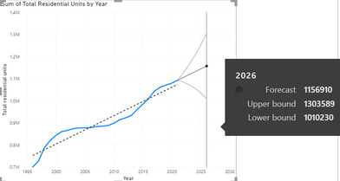

This is a line chart showing the total residential units plotted against the year tracing all the way back to 1996, till last updated 2021, and even forecast till 2026. The three extended "whiskers" you see in the chart are the upper bound, median and lower bound of the forecasted residential units until 2026.

**Percentage of common dwellings found in Singapore**

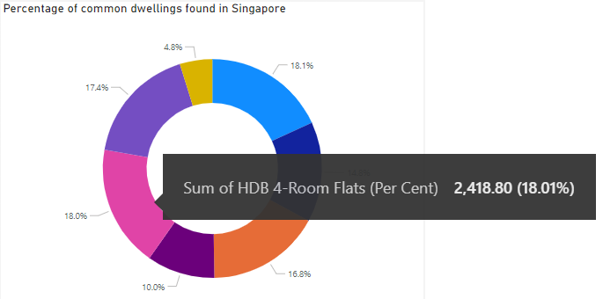

​

Here is a Donut chart which shows the percentage of all the different flat houses and private properties available in Singapore.

**Top 10 flat models**

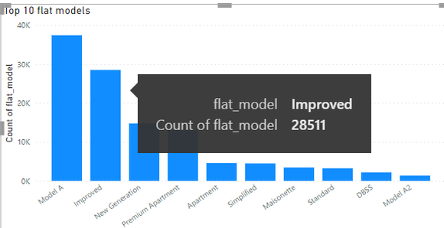

This visual shows the count of respective flat models sold sorted in descending order. It is a vertical bar chart with the count of flat models plotted against the variety of common flat models.

**Most sought after Regions**

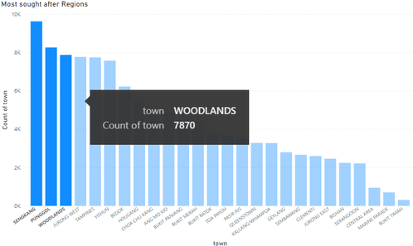

Similarly, this is a vertical bar chart that shows the total count of properties sold across Singapore. From the dashboard, we can directly see that Seng Kang, Punggol and Woodlands are the Top 3 regions with the most number of flats sold!

**Most bought flat types**

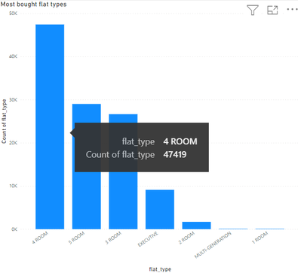

From this visual, the 4-room and 5-room flats are the Top 2 flat types with the most number of flats sold. This result can be derived easily by plotting the count of flat types sold against the respective flat types. Buyers of these flats are usually families of at least 4 pax and above!

**Map chart showing the count of flats sold across Singapore**

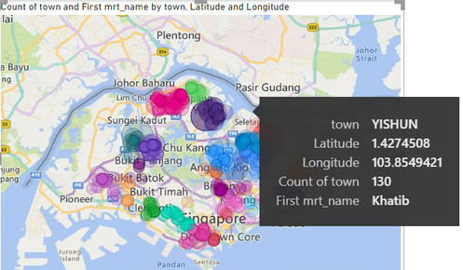

​Unlike the bar charts, this Map chart allows users to instantly identify the regions that have either recorded the highest number of properties sold or the lowest number of properties sold.

## **6.3 Iman**

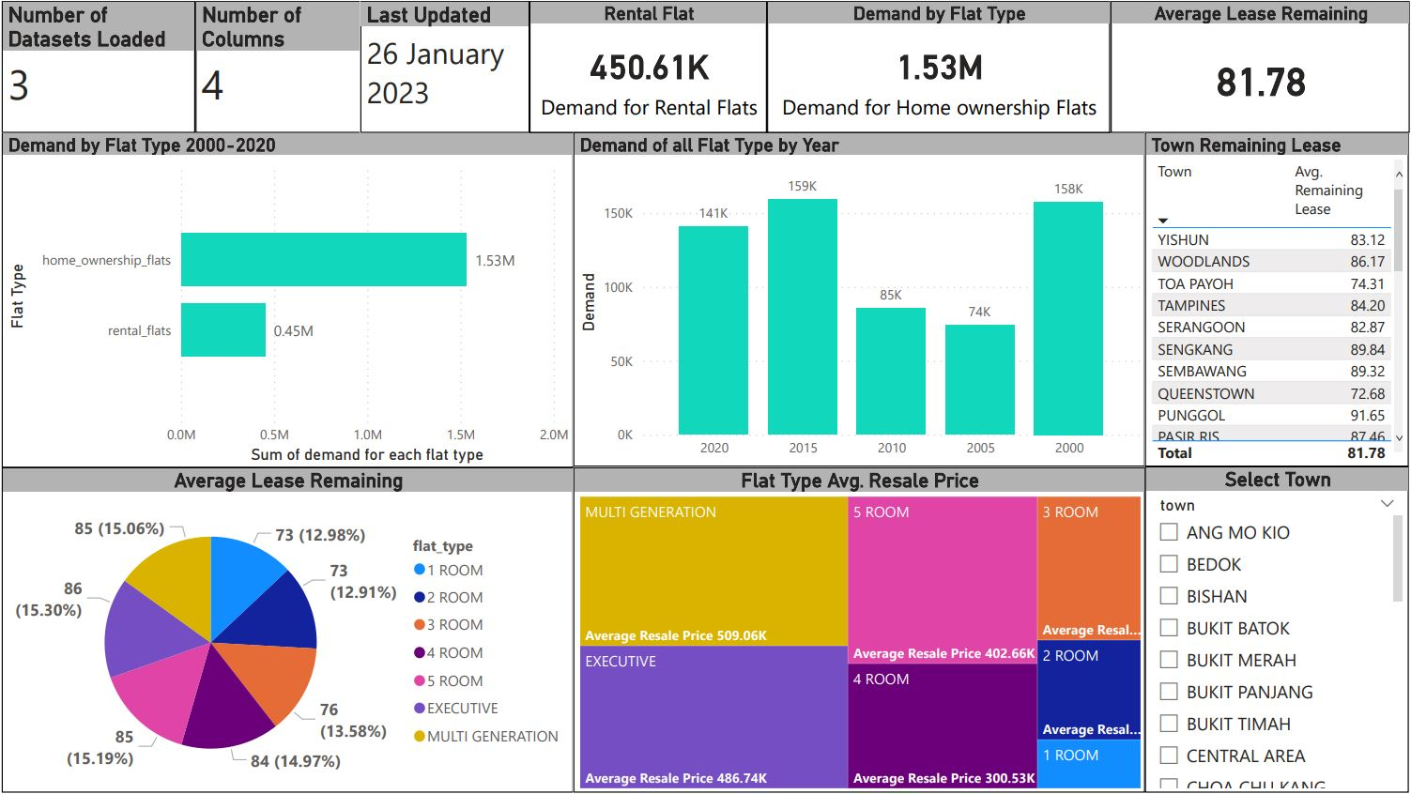

The picture above shows a dashboard from Power BI. In summary, the dashboard 4 of visualisations for the comparison of demand, average lease remaining for flat types, and average resale price for each town. There are three datasets that were used, and the datasets are:

1. ALL Prices 1990-2021 mar.csv
2. demand-for-rental-and-sold-flats.csv
3. resale-flat-prices-jan-2017-onwards.csv

Some of the columns in the datasets were removed as they were deemed trivial. The dataset that will be focused mainly is demand-for-rental-and-sold-flats.csv

Some people take the leasing period for granted. If you were to purchase a flat with less than 75 years left or plan to give it to the next generation, it would be a problem down the road. Everyone should consider buying a flat that is at least 75 years or more. A 99-year lease can at most hold a house for two generations. Homebuyers should consider the lease period as one of the top factors when purchasing a flat.

**Demand by Flat Type**

​In this bar chart, it shows the comparison between flats under an ownership and rental flats. Both are being compared by the demand from the year 2000 to 2020. Home owned flats are being demanded more compared to rental flats as most people recognise rental flats as a temporary housing solution.

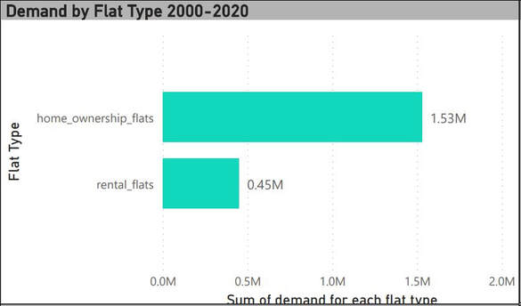

**Demand of all Flat Type by Year**

​In this column chart, the demand for all flat types is shown every 5 years starting from 2000. 2015 has the highest number of demands and 2005 has the lowest number of demands. The high number of demands in 2015 could be from marriages and family formation. It could also mean that more people, specifically young couples or elderly with adult children want to live in their own flats instead of living together, or there could be more single users to own a home.

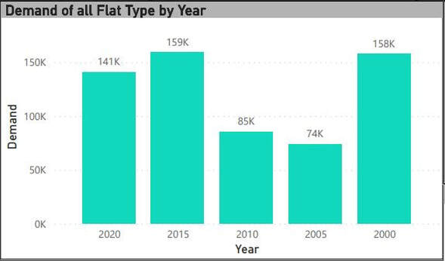

**Average Lease Remaining**

​In this pie chart, all the flat types are shown here with their average remaining lease in 2020 throughout the entire Singapore. Executive flats have the highest average remaining lease, with it having an average of 86 years left. 5-Room and Multi Generation flats have the same remaining lease, with both having an average of 85 years left. 1 Room and 2 Room flats have the least remaining average least left, with an average of 73 years left. Home buyers should avoid flats with less than 73 years as problems will appear throughout the years.

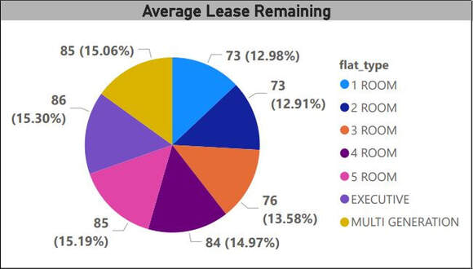

**Flat Type Average Remaining Lease**

In this treemap, the flat types are shown with their average resale price. Multi Generation has the highest resale price as they are a new type of HDB flat, it has a larger space and consists of 4 bedrooms and 3 bathrooms. Executive comes in second as it has 1 bedroom with 1 attached bathroom, additional 2 bedrooms and another bathroom. 5 room flat comes in third as it consists of 3 bedrooms and 2 bathrooms.

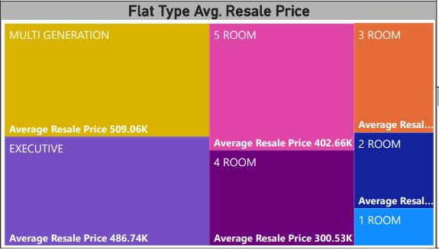

## **6.4 Kelven**

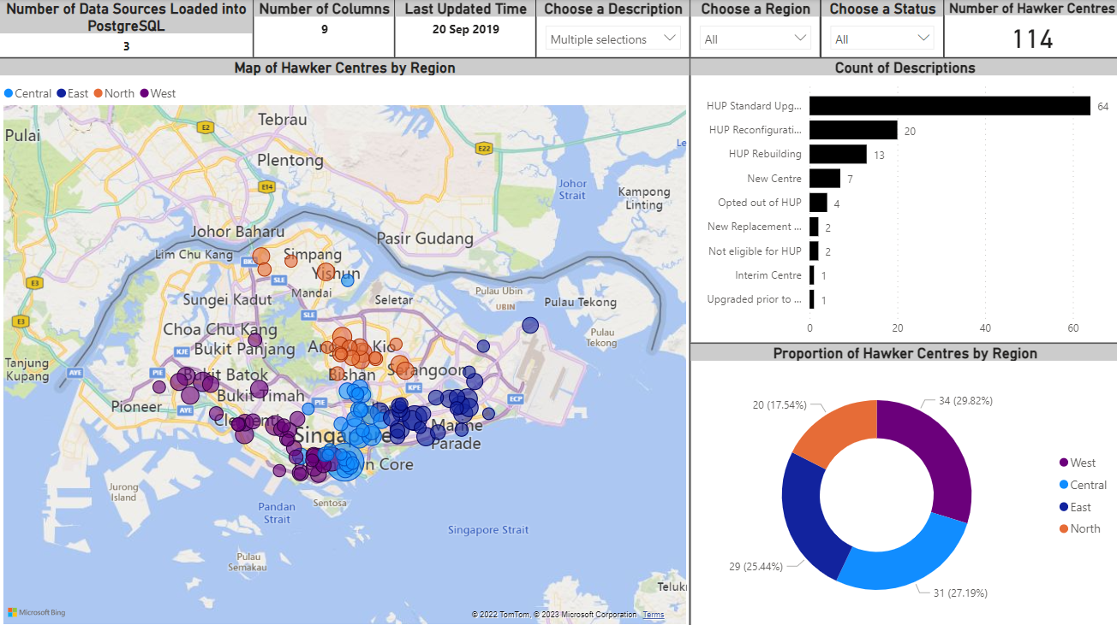

The image above shows a dashboard using Microsoft Power BI. The dashboard comprises 4 text boxes, 3 slicers, and 3 visualisations.

The 3 visuals are as follows from left to right, top to bottom:

* Map of Hawker Centres by Region
* Count of Descriptions
* Proportion of Hawker Centres by Region

I sourced 3 datasets:

* hawker-centres-kml.csv
* parks_playgrounds.csv
* supermarket.csv

Even though I loaded the 3 datasets into the database, this dashboard only focuses on hawker-centres-kml.csv dataset. During data cleansing, some columns were removed as they were deemed trivial.

As seen from the dashboard, the main target audience of this dashboard is parents. It also shows that there is a total of 114 hawker centres across 4 regions: North, Central, East, and West. The Status of each hawker centre is either "Existing" or "Existing (new)". Selecting different options for the slicers changes the visuals.

Before creating the dashboard, I connected Power BI to the group Azure database. The steps used to connect can be seen in my DataOps process previously.

**Map of Hawker Centres by Region**

The map shows the locations of each hawker centre in Singapore grouped by region. Each bubble has a different size; bigger bubbles signify a greater number of food and wet market stalls and vice versa. This map also shows the distribution of hawker centres across Singapore. It is observed that there are few hawker centres in the northwest, north, and northeast of Singapore. In the south of Singapore, there seems to be a cluster of hawker centres. There are also clusters at Ang Mo Kio and Bedok.

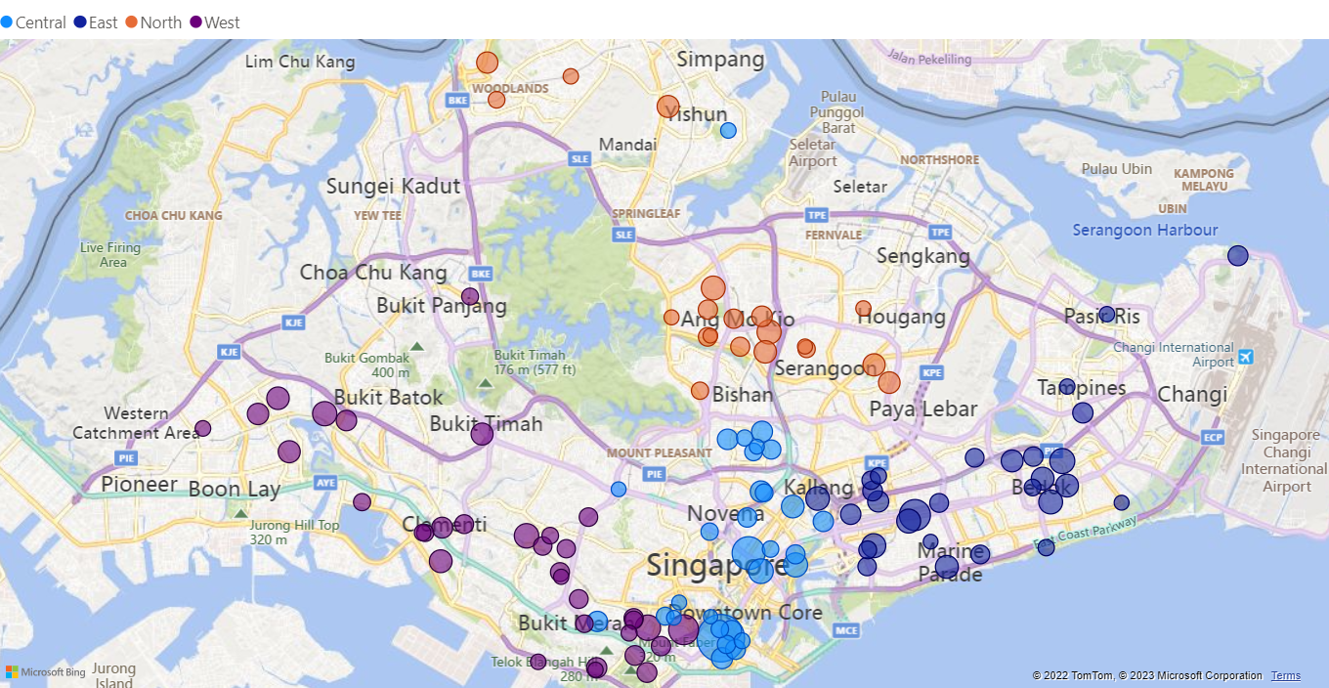

**Count of Descriptions**

The bar chart shows the number of hawker centres with different descriptions. The values change depending on the chosen slicer options (Region, Status). Most centres have Hawker Centre Upgrading Programme (HUP) Standard Upgrading. Hawker centres that are upgraded under HUP are more spacious, have bigger dining tables, and are more accessible to wheelchair users and prams. The improved facilities also mean the centres are more hygienic These can be beneficial to big families, families with a wheelchair user, or families with young children.

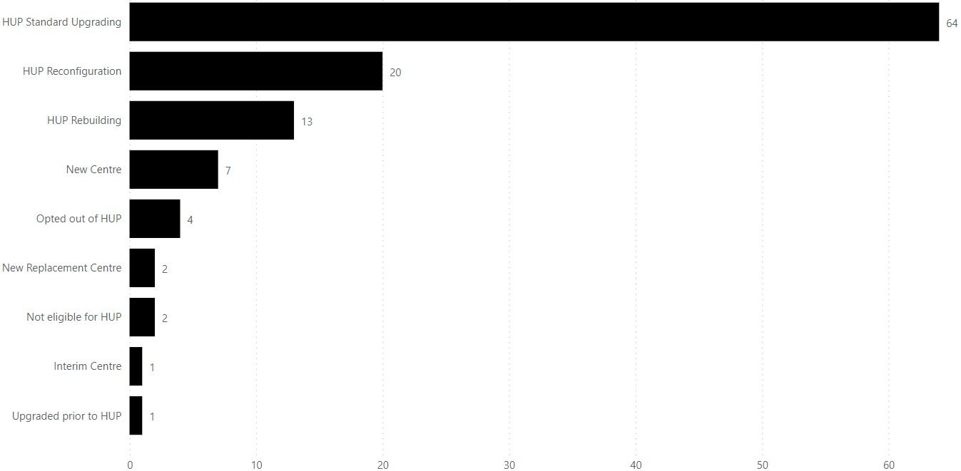

**Proportion of Hawker Centres by Region**

The donut chart shows the proportion of hawker centres by region. It is observed that the West has the most number of hawker centres while the North has the least. The proportion changes depending on the chosen slicer options (Description, Status).

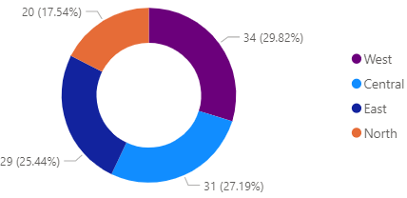

## **7. Reflection**

## **7.1 Ambrish**

Using this Agile methodology has been insightful in many ways as it gave me a clear perspective of what it is like and what to expect regarding the workflow in the industry. It turned out to be helpful in many ways, including outlining the roles and responsibilities of each group member. The Agile methodology greatly aided me as I became more aware of my tasks and how to achieve them and work to proceed without interruption in a smooth manner. It also allowed me to concentrate and work on my communication abilities. My group and I were hesitant about how to approach this assignment because we were unsure of the expectations, which halted our progress. But after having a few discussions about our goals, we were able to band together and finish the job. This assignment allowed me to practise my time management abilities. Since each sprint was 2-weeks long, it appeared impossible for me to finish all the tasks by the sprint's end. But due to my well-thought-out itinerary, I could complete everything on time and to the best of my abilities.

## **7.2 Chong Xiang**

Benefits:

Everything was detail-oriented and organised. During each sprint, each member was assigned tasks and knew the objective since these tasks were specific and accomplishable by the deadline. The scrum methodology allows for better group progression as the tasks were not too ambitious. This allows all group members to smoothly complete their tasks by the sprint review during the second mid-week of our group’s two-weeks sprint cycle.

Challenges:

There is a potential inaccuracy regarding what I think my key stakeholders (users) need. Since we are not individuals looking to buy a property, we could not fully empathise with our stakeholders' needs. They have many needs and requirements apart from pricing, and only then will they consider buying it. However, this matter will mostly only apply to niche groups of buyers since my group and I considered the majority of buyers’ opinions and actual demands in this project. Therefore, inaccurate assumptions of these housing requirements should not happen to the vast majority of these buyers.

## **7.3 Iman**

For my user story, HDB, I had to know the remaining lease period for an HDB area. As this is my first time being in a team with an Agile approach, I could communicate with my teammates, gain advice from them, learn to manage my time better, do my tasks on time, and catch up on the team's progress as a Scrum master. As this is my first time using Airbyte, I encountered problems with it the first time. Subsequently, it worked the second time but failed again at a later date. This taught me to start my tasks earlier so that I could resolve any issues earlier. Despite the flaws and errors in my work, I learnt life skills such as time management, communication, problem-solving and decision-making. I was puzzled at the start as I did not understand what was happening in the assignment. But as I went through the meetings, read the PDF file carefully, and researched some information on my own, I was able to catch up with the team.

Many challenges for me obstructed my progress in this assignment. Time is limited, and I kept taking it for granted by telling myself I had lots of time. But in reality, I only had so little. Communication was also challenging as I am very timid and rarely talk. I also had other assignments, so I had to balance the work for all of them. The main challenge for me was that I could not understand some of the terms or objectives in this assignment. To resolve this, I asked my teammates or the teacher to elaborate further so I could understand clearly.

## **7.4 Kelven**

Using Agile and Scrum for this assignment allowed me to plan and manage my time. The agile framework taught me to empathise with the users, which allowed me to ideate better problem statements. My team could plan each sprint and break down each task using Scrum and the scrum board. The planning made the overwhelming number of tasks more doable, and doing small chunks across many sprints made the assignment easier.

However, throughout the assignment, there were some challenges. At the start, we were confused and unsure of how to begin. Thus, we made no progress on our first sprint. Since this assignment had begun early in the semester, I was complacent and procrastinated, which piled up the tasks for later sprints.

To resolve this, my team met up and re-planned our story backlog, which cleared up our confusion and allowed us to tackle the assignment more effectively.

During this assignment, there were occasions where my team had to change and add tasks. For example, one of our first tasks was creating a Wix website. But we later altered it to a Weebly website. And during the final sprint, we added tasks such as Finish Report, Create Slides, Add Codes to GitHub Repository. If this assignment was done through the waterfall framework, these changes and additions would not be possible.

## **8. Website Links**

Trello Scrum Board: <https://trello.com/invite/b/vNERNh9T/ATTI592900f36a14da649211ecd3269952bb5A547A2D/ado-asg2-scrum-board-grp3>

PostgreSQL

Server name: np-dataops-grp3.postgres.database.azure.com

Admin username: KelvenLim@np-dataops-grp3

Admin password: 24A675223b04

GitHub

<https://github.com/KelvenLim/ADO-ASG2-Repo>

Weebly website

<https://ado-asg2-group3.weebly.com/>